CITIZENS
MANUAL

Georgia Boys State



Sponsored by the
American Legion
Department of Georgia

GEORGIA BOYS STATE CREED

American Citizenship is a most priceless possession. I believe in the constitutional form of government of the United States of America - which guarantees me the right to worship God as I choose and as a citizen, equal opportunity, and equal educational rights. It is my obligation to participate in and contribute my effort to the civic and political welfare of my community, state and nation.

I resolve to learn and understand government and the civic needs of my community and I hereby dedicate myself to the task of arousing and maintaining a like interest in my fellow citizens.

Therefore, may the experience of Boys State be ever with me as a reminder of my obligation to my country.

GEORGIA BOYS STATE PLEDGE

As a citizen of GEORGIA BOYS STATE, I voluntarily make the following pledge:

I WILL: get written permission from the Director should I leave the Boys State area.
I WILL: obey the statues, rules and regulations of Georgia Boys State.
I WILL: take a serious and conscientious interest in discharging my duties as a citizen of Georgia Boys State with dignity and honor to my State, town and city.
I WILL: adhere to the program of Georgia Boys State, participation in government and recreational activity as scheduled, including special classes that I select beyond the regular routine.
I WILL: serve, if elected to office, to the best of my ability.
I WILL: respect the judgment of my superiors such as counselors, advisors, and others appointed by the proper authority of the American Legion.
I WILL: not form injurious habits while at the Georgia Boys State which I do not practice at home, such as smoking.
I WILL: not use, nor tempt other citizens of Georgia Boys State to use alcoholic liquors while Georgia Boys State is in session.
I WILL: contact my home folks at least two times during the week of Georgia Boys State, and I will notify my sponsor in writing of any office I hold.
I WILL: make a written report to my sponsor, or sponsors, (which I shall deliver personally) upon my impressions of Georgia Boys State on my return home.
I WILL: make conscientious reports on time.
I WILL: protect and conserve all property of the Georgia Boys State and likewise the property and grounds of the host facility.
I WILL: keep my own quarters tidy and clean at all times and at the same time keep the Georgia Boys State area clean and organized so that visitors will be impressed with the general appearance of Georgia Boys State at all times while I am a citizen therein.
I WILL: respect the rights of my fellow citizens of Georgia Boys State.

Signed_____________________________
Dear Georgia Boys State Delegates

Welcome to Georgia Boys State!
This week you will learn how to actively and effectively engage in your government. Back home many of you are already actively participating in school, community, and local government in many different areas. Because of the civic leadership you have shown in your community you were hand selected for the Georgia Boys State program.

This manual was prepared especially for you – to help you get the most out of your week as a citizen of American Legion Georgia Boys State. Read it carefully and thoroughly just as soon as possible. Refer to the manual from day to day as you go into the various phases of your activity. The more familiar you become with the contents of the manual, the greater will be your advantage in party conventions and caucuses – as well as in the elections. Keep it for future reference.

All staff members of Georgia Boys State have one purpose in mind – TO HELP YOU THOROUGHLY ENJOY GETTING A GREAT DEAL OUT OF "BOYS STATE!" Each one of us is first of all your friend, so don't mind bringing us any problem or question.

Here's wishing each of you a week of successful campaigning! We now leave the success of this week in your hands. We encourage you to plan which offices you wish to run for, campaign hard, and even if you are defeated learn from your experiences. This week is ultimately what you make of it.

Let's make Georgia Boys State a model for all the states in the Union. Please remember the test of how much you learn here begins when you leave this campus and lasts the remainder of your life.

THE STAFF

CONTENTS

SCHEDULE
Sunday 7
Monday 7
Tuesday 8
Wednesday 10
Thursday 11
Friday 12
Saturday……………………………………………………………………..…………………………………….12
Section I INTRODUCTION TO GOVERNMENT.....................................................................13
Government in Georgia 14
Georgia's Laws 15
Elections in Georgia 16
Political Parties in Georgia 16
City Government 16
Mayor-Council type 16
Manager Type: 17
County Government 17
Solo-Commissioner type: 17
Board-of-Commissioners type: 17
Other County Officers: 18
State Government……………………………………………………………………………………… .……...18
Executive Branch……………………………………………………………………………………………..….18
Constitutional Boards 20
Statutory Offices and Boards 20
Judicial Branch 20
Legislative Branch 21
How a Bill becomes a Law in Georgia 22
Section II GEORGIA BOYS STATE GOVERNMENT 28
City and County Alignments 29
Nominations and Boys State Offices 29
Campaigns 30
Elections 30
Section III GEORGIA BOYS STATE CITY GOVERNMENT 31
City Conventions, Elections and Government 32
City Conventions 32
City Elected Officials 32
City Organization 32
Functions and Duties of City Officers 32
City Courts in Session 34
Georgia Boys State City Charter 35
ORDINANCES OF CITIES 36
Section IV GEORGIA BOYS STATE COUNTY GOVERNMENT 37
County Conventions Elections and Government 38
County Conventions 38
County Elected Officials 38
County Organization 38
Functions and Duties of County Officers 38
County Courts in Session 39
Section V GEORGIA BOYS STATE CONVENTIONS/ELECTIONS/GOVERNMENT 40
State Conventions, Elections and Government 41
State Party Organization 41
State Executive Committee 41
State Conventions 41
State Organization 42
Legislative Branch 42
Executive Branch 43
Judicial Branch 43
Functions and Duties of State Officers 43
Executive Branch 43
Legislative Branch 45
Judicial Branch 45
Parliamentary Procedure 45
Conduct in Meetings 46
Transmittal Letters 47
Oaths of Office 47
Procedure–House of Representatives and Senate 48
Order of Business 48
Procedure in Committee of the Whole 48
Rules – Senate and House of Representatives 49
Georgia Boys State Laws……..……………………………………………………………………………….…...50

Charts

State Budget Process in Georgia 23
How a Bill is Passed in the Georgia Legislature 24
Georgia Electorate 25
Hierarchy of Law in Georgia 26
Motions 51
Parliamentary Procedure 52

INTRODUCTION TO GOVERNMENT

Section I

Introduction to Government

This manual is designed as a guide rather than a text. Its purpose is to present a brief outline of the governmental structure of the State of Georgia and of her counterpart, the Georgia Boys State.

A government is an agency established and operated by men and women for the purpose of meeting the common needs, encouraging the ideals, and promoting the sound development of the people within its jurisdiction. The more complex a civilization becomes, the greater the need for government.

A government differs from a voluntary association in many ways. Its jurisdiction extends to all persons within its territorial limits. No such person can voluntarily withdraw from the rule of the government unless he leaves the territory within which its powers are exercised, and in that event, he finds himself still ruled by a government, though a different one.

Government is unlike private business in that it does not seek profit, but is maintained through taxation. Everyone pays some form of tax to the government, either direct or indirect. It is well to remember that the person from whom the government collects a tax is not always the one who actually pays it, since most taxes are shifted to the consumer or client of the property or business on which the tax is levied. If a government increases its services to the citizen, it must meet the added cost by collecting more taxes from him.

Government acts by law and through public officials. In some nations, laws (edicts, decrees) largely flow from a single official, known formerly as a monarch or tyrant, now as a dictator. In our State and Nation, from the beginning of our independent existence, laws have had their source in the people themselves, and this is our assurance of liberty. Our government is a democratic republic, and in spite of all the imperfections (and there are many) imposed upon it by human nature and conduct, this form of government is throughout the course of history the highest achievement in group self-control. In conception as well as in reality it is the greatest giver of individual liberty. To us, the direct beneficiaries, its blessings are so commonplace that we often fail to realize their worth, and we are often dangerously unaware that our liberty is threatened by those (within and without our country) who distrust, deny or betray democracy.

We must always remember that any type of government is formulated and operated by human beings, and no human beings are perfect. Democracy, since it is operated by human beings, is subject to human limitations. It is not perfect because they are not perfect, but it is the form of government which gives the people living under it the highest measure of freedom and opportunity.

The pattern of American government is distinguished by these features: The sovereignty of the people, expressed in a written Constitution, which includes a Bill of Rights, creates three branches of government, provides for the separation of powers, and the system of checks and balances.

We live under two Constitutions – the Constitution of the United States and the Constitution of the State of Georgia. Both incorporate the same basic features, but they differ in one important respect: The Federal government can exercise only the powers delegated to it by the States and enumerated in the United States Constitution. Each State government can exercise all remaining governmental powers except those reserved to its people by their State Constitution.

Government in Georgia
The government of our State, one of the Original Thirteen, follows the American pattern of Government. While there have been many changes and developments in the details of the organization, the system itself remains fundamentally the same as originally conceived. The people remain sovereign, and the Constitution itself challenges anyone who would trespass on individual rights, or exceed the bounds of his authority.

Sovereignty of the People: The government of Georgia was established and is maintained through the sovereign will and consent of its citizens, expressed through the State Constitution which cannot be amended or revised without a direct vote of the people.

Written Constitution: Georgia's tenth Constitution became effective in 1983. The Constitution itself provides the procedure for its revision and amendment.

Bill of Rights: Nothing is more vital to all of us than our personal freedom. No part of the Constitution is more important than the Bill of Rights, which safeguards freedom of worship, liberty of speech and of the press, right of trial by jury, protection against unreasonable searches and seizures, and the other recognized guaranties of individual freedom. So long as the Bill of Rights is observed in spirit as well as in letter, our liberties are secure. The Georgia Bill of Rights is set out in Article 1 of our Constitution.

Three Branches of Government: In Georgia, the three traditional branches of government remain separate, as follows: The Legislative (The General Assembly), The Executive (The Governor and other administrative officials and their assistants), and The Judicial (The Supreme Court and the Court of Appeals are the Appellate Courts. The Superior Courts, The City and Municipal Courts are the Trial Courts).

Separation of Powers: The Georgia Constitution, like the United States Constitution, embodies the principle of separation of powers. The General Assembly makes the law, the courts interpret them, and the Governor and other officials administer and enforce the laws thus made and interpreted.

Checks and balances: There are, however, certain instances when one branch may "pull rein" upon another, and thus temper excess zeal or faulty judgment. For instance, the Governor has the power to veto the acts of the General Assembly, and may thus require reconsideration of any law or appropriation, and a two-thirds vote instead of a majority of each House is then necessary to bring about its final enactment.

Georgia's Laws
Our laws are of three kinds, listed in the order of their superiority:

Constitutional Law is the fundamental law, contained in a single document that declares principles rather than prescribes practices, is concerned with doctrines rather than with details. It is the foundation upon which the whole structure of our government rests.

Statutory Law is law made by the General Assembly under the authority given by the Constitution. Since the people elect the General Assembly, this kind of law, too, stems from them. The laws enacted at each session of the General Assembly are printed, and at intervals all laws of general application in force are compiled and systematically arranged in a Code. The latest such Code in Georgia is that of 1982 titled the “Official Code of Georgia Annotated.”.

Common Law is not found in a single document or in a written Code or compilation. It is the great body of unwritten law founded upon custom, general usage, or common consent, and on natural justice or reason, established by precedents and maintained by judicial decision. The colonists brought our common law here from England. A considerable part of it has now been enacted as statutory law. Whenever there is a conflict between the principles of the common law and the statutes of the Constitution, the latter, of course, prevail.

A governing body of a city or county may adopt local ordinances and resolutions pursuant to authority contained in its charter as enacted by the General Assembly, but these are in force only within the territory of the city or county.

Elections in Georgia
All elections in Georgia are provided for by the Georgia Election Code which is Chapter 2 of Title 21 of the Georgia Code also known as the “Georgia Election Code.” This includes Primary Elections, which are conducted for the purpose of nominating party candidates, and General Elections, which are conducted for the purpose of electing from the party nominees the official office holder.

The State Election Board supervises and coordinates the work of conducting all of the elections in the State of Georgia. The law provides that the Secretary of State shall be Chairman of the State Elections Board.

Political Parties in Georgia
The highest party authority in the state is the State Party Convention. Next in authority is the State Party Executive Committee.

In addition to the Party Executive Committees, there are Party Executive Committees in each Congressional District, in each State Senatorial District, in each House of Representatives District and in each county.

The County Executive Committee may be a part of a Senatorial District Committee and a part of a House of Representatives District Committee. However, in some instances the County Executive Committee has within its boundaries one or more State Senatorial District Committees and one or more House of Representative District Committees.

City Government
There are over 600 incorporated municipalities in Georgia. Each municipality is created by a special act of the General Assembly, which act sets out the charter of the city. As the city is the creature of the General Assembly, the General Assembly can at any time change these powers and amend or even revoke the charter, though in cities of under 50,000 population such action is subject to local referendum.

In general the municipal governments of Georgia are of two types – the Mayor-Council type and the City Manager type.

Mayor-Council type
City Council: This is the City's governing body, and consists of 3 or more members; In some cities all are elected by the city at large, while in others each councilman is elected from and by a single ward. The Council determines the general policies of the city. By ordinance it grants public utility franchises, establishes public libraries, parks, etc. and makes regulations concerning traffic, zoning, street lighting, health, sanitation, and the control of certain types of businesses. An ordinance is drafted in the same manner as a bill introduced in the General Assembly. It must have an enacting clause, usually in the following form: "BE IT ENACTED by the Mayor and Council of the City of ________________ as follows:" Finally, it must have an effective date.

(1) Mayor: The Mayor is the Chief executive of the city, elected by the people. He usually presides at meetings of the council; he has the power to call Council's attention to the City's problems and to recommend action thereon. Usually, he has the power to veto ordinances and resolution, which can then be re-enacted by Council only by an increased vote, usually two-thirds. He has general supervision over the executive branch of the city government.

(2) Recorder: This official, usually elected by the people, presides over the city Police Court, with jurisdiction to try violations of city ordinances, and to bind over to the Grand Jury all persons accused of violating State Laws where the evidence indicates suspicion of guilt. This suspicion of guilt must be of such gravity to require a trial by Jury. In small cities the Mayor often acts also as recorder.

(3) City Attorney: Usually appointed by Council, although sometimes elected by the people. He is the legal adviser of Council and other city officials. He prepares all contracts and ordinances, prosecutes cases in the Recorder's Court when required, and represents the city in all other cases where the city is a party.

(4) City Clerk: Usually chosen by the Council; keeps the minutes of that body and all other documents relating to city affairs. Issues city licenses and permits; sometimes collects all revenues and taxes for the city.

(5) City Treasurer: Also usually chosen by Council; has custody of the city funds and keeps the financial record.

(6) City Police Chief (sometimes called the Marshal): Appointed by Council or the Mayor, this officer is charged with direct responsibility for law enforcement and the preservation of order within the city, with power to arrest offenders.

(7) City Fire Chief: Appointed by Council or by the Mayor, is responsible for fire prevention and fire-fighting within the city.

(8) City Parks Superintendent: Appointed by Council or by the Mayor, has charge of the city's parks, playgrounds and other recreational facilities.

(9) City Health Commissioner: Is usually appointed by Council or by the Mayor and is charged with the promotion of health and the enforcement of health and sanitary regulations.

Other officers such as the city engineer, city assessor, waterworks superintendent, planning commission, civil service commission, hospital superintendent, and so on, are usually appointed by the Mayor, sometimes subject to confirmation by the Council.

Manager Type:
Under this type of city government the city council is the governing body, just as under the other type, determining the city's general policies and enacting all ordinances and resolutions. The Mayor, however, is simply a member of council, chosen by that body from its own number to preside at Council meeting and act as ceremonial head of the city but without executive power. The chief executive of the city is a City Manager chosen by Council on merit only for an indefinite term and serving at its pleasure. He is selected for his administrative ability and appoints and removes all heads of departments and subordinate officers on the basis of merit and fitness. He is personally responsible for administrative discipline throughout the city government. He meets with the Council, but has no vote. With the above exceptions the other city officers under this type are similar to those under the Mayor-Council type.

County Government
Each of the 159 counties in Georgia is operating under one of the four types of county government authorized by law: The ordinary type; the single-commissioner type; the board-of-commissioners type; or the county manager type.
The only state with more counties than Georgia is Texas. Three consolidated governments are included in the total number of counties: Columbus-Muscogee, Athens-Clarke, and Augusta-Richmond.
Counties may be organized using the traditional commission, sole commissioner, elected executive, commission-administrator, or commission-manager form of government. County governments in Georgia have anywhere from one to nine commissioners.
The legislature at any time may change the type of government in a county from one type to another, even though the citizens of the county may protest against the change.

Solo-Commissioner type:
In several counties, a single commissioner is the head of the County government.

Board-of-Commissioners type:
In most of our counties is a Board of Commissioners of two to nine members. They choose one of their members Chairman who presides at their meeting, but has no more power than any other member of the board. In this type there is no single executive, the board as a whole performing the functions that in the other counties are performed. The people of the county usually elect its members at large. In several counties, the members are elected from districts and the county elects the chairman at large instead of being selected from the board of commissioners.

County Manager type:

Several counties now operate under this type of government. This type is similar to the city-manager type in cities. The county manager being the executive head is appointed by and responsible to a county board of commissioners whose functions are policy determining only.

Other County Officers:

Every county has a Judge of Probate elected by the people. His normal powers are to act as judge or probate, supervising the administration of the estates of deceased persons, lunacy commitments, etc.

Some counties has an elective Treasurer, though in most counties a bank is designated to perform these functions, which are to have custody of county funds and keep account of the receipt and disbursement of the same.

Every county has a Clerk of the Superior Court elected by the people, who keeps the records of the Superior Court and may also keep the records of other local courts if he has been designated as the clerk thereof. This official also keeps deeds, mortgages, plats, and other documents of title to land as well as chattel mortgages.

Every county has a Sheriff elected by the people. He is the executive officer of the courts. In most counties he is both a civil and criminal officer, that is, he carries out the court’s orders as to “serving” papers (delivering them in person to the individual for whom they are intended), and also arrests persons charged with crime. In some counties that have a county police department, however, he is relieved of his criminal duties. The papers, which he serves, include subpoenas or other notices to appear before the court, notices that a suit has been filed affecting the individual notified. When the court so orders the Sheriff also sells property involved in litigation.

Many counties have a Tax Receiver elected by the people. The Tax Receiver receives annually each taxpayer’s property tax return (formal declaration of the property he owns on January 1st of that year, the value thereof and the intention to pay taxes thereon), and lists same in a book called a “tax digest”. Many counties also have a Tax Collector elected by the people, who (1) completes the tax digest by applying the tax rate to the tax values and determining the amount of taxes due, and (2) collects these taxes.

Some counties, however, instead of having a tax receiver or a tax collector, have a single Tax Commissioner who performs the functions of both offices. The Tax Commissioner is also elected by the people.

Every county has a County School Superintendent, elected by the people or the Board of Education to administer the county’s schools exclusive of independent city districts.

Every county has a County Surveyor elected by the people, who surveys county and district boundaries and makes other surveys of land when required by the courts.

In addition, there are numerous appointive officials such as board of tax assessors, appointed by the county commissioners to review and equalize property values on the tax returns; a county attorney, appointed in the same manner to represent the county in suits and legal transactions; and a county warden or engineer. The director of Public Welfare is with the approval of the State Welfare Director, to administer aid to the needy. Some counties or groups of counties have a county Health Commissioner, appointed by the County Board of Health with the approval of the Director of the State Department of Health. Each county also has a Board of Jury Commissioners and a Board of Registrars.

State Government

Executive Branch
The people elect the following state officials:

Governor: The chief executive of the State is the Governor. To be eligible one must be at least 30 years old, a citizen of the United States for 15 years and of Georgia for 6 years. The Governor’s term is 4 years and he may succeed himself for another 4 year term, after which he must be out of office for one term before being eligible to hold the office again.

The Governor is required to see that all laws are executed and he has power to use the State’s military forces for this purpose as well as to repel invasion or suppress insurrection. The Governor grants commissions to all officers, including United States Senators and Representatives. He has power to suspend the collection of any State tax or taxes until the next meeting of the General Assembly, but no longer. All payments from the State treasury can be made only on his warrant. He is ex-officio Direction of the State Budget, and as such may inquire into the methods of conducting the affairs of every State Department. He shall prepare and submit to the General Assembly a budget report and recommendations for appropriations. He has power to suspend the execution of death sentences, but only until the State Pardon Board (or, in treason cases, the General Assembly) considers the case. He appoints many of the officials of the State, subject to the Senate’s confirmation. He can call special sessions of the General Assembly and prescribe the matters to be considered at said special session. Every bill passed by the General Assembly must be presented to the Governor before it becomes a law. He may disapprove it within five (5) days, and if he does so it does not become a law unless reconsidered and passed by a two-thirds majority of the members elected to each house of the General Assembly. If he fails to act, it becomes law anyway unless the General Assembly adjourns within the five-day period.

Lieutenant Governor: The officer acts as Governor upon the Governor’s death, resignation, or disability, and until the next biennial election. When not acting as the Governor, he presides over the Senate. To be eligible one must be at least 30 years old, a citizen of the United States for 15 years and of Georgia for 6 years.

Secretary of State: This officer keeps the Great Seal of the State, all the original acts passed by the General Assembly, and most of the other public records of the State. He supervises State elections and canvasses election returns on Constitutional amendments and on all state and county officers except State constitution officers and the United States Senators and Representatives. He enforces the Georgia laws regulating the issue and sale of securities and the use of trade marks. He grants charters to public utility corporations and certifies for the State, the charters of all other corporations granted by the Superior Courts. He supervises the preservation and study of the State's records by the Division of Archives and History and keeps all records for the various State Examining Boards which determine who shall be licensed to practice certain professions and trades in Georgia. To be eligible one must be at least 25 years old, a citizen of the United States for 10 years and of Georgia for 4 years.

Attorney General: This officer is the legal advisor of every other officer and department in the Executive Branch of the State government. He represents the State in the Supreme Court in all cases of capital crime (those for which the punishment is death), and in all civil and criminal cases in any court when directed by the Governor, and shall perform such other duties as shall be required by law. To be eligible one must be at least 25 years old, a citizen of the United States for 10 years and of Georgia for 4 years. He must have been an active status member of the State Bar of Georgia for seven years.

Commissioner of Insurance: To be eligible one must be at least 25 years old, a citizen of the United States for 10 years and of Georgia for 4 years. In addition to duties associated with the insurance trade in Georgia, this official is also the State Safety Fire Commissioner, Industrial Loan Commissioner, and the Comptroller-General

State School Superintendent: This officer must be at least thirty years old, with either three years practical experience in teaching, or a diploma from a reputable college or normal school, or five years experience in school supervision. He has general supervision over the entire educational system of the State.

Commissioner of Labor: This officer superintends the enforcement of Georgia labor laws and the administration of the unemployment insurance system. To be eligible one must be at least 25 years old, a citizen of the United States for 10 years and of Georgia for 4 years.

Commissioner of Agriculture: This officer must be a "practical farmer." He studies insects injurious to crops, inspects fertilizers and prohibits the sale of those failing to pass his test, collects statistics on farming and farm products, administers the State's pure food laws, and in general promotes the improvement of agriculture. He has general supervision of the State's Farmers' Markets. To be eligible one must be at least 25 years old, a citizen of the United States for 10 years and of Georgia for 4 years.

Public Service Commission: (5 members). This body regulates public utilities in Georgia, including gas, electric, telephone, telegraph, railroad, bus and truck companies and the rates they charge the public for service.

Constitutional Boards
STATE BOARD OF PARDONS AND PAROLES—5 members appointed by the Governor, subject to confirmation by the Senate for a 7 year term. The members of the board from its membership shall select the chairman.

STATE PERSONNEL BOARD—5 members appointed by the Governor, subject to confirmation by the Senate for terms of 5 years. The members of the board from its membership shall select the chairman.

STATE TRANSPORTATION BOARD—One member from each congressional district elected by a majority vote of the members of the House of Representatives and the Senate whose respective districts are embraced or partly embraced within such congressional district. The members serve for 5 year terms. The State Transportation Board shall select a commissioner of transportation.

VETERANS SERVICE BOARD—7 members appointed by the Governor, subject to confirmation by the Senate for terms of 7 years. The board shall appoint a commissioner who shall be the executive officer of the department. Members shall be veterans of some war or armed conflict in which the United States has engaged.

BOARD OF NATURAL RESOURCES—One member from each congressional district in the state and five members from the state at large, one of whom must be from one of the following named counties: Chatham, Bryan, Liberty, McIntosh, Glynn or Camden. The Governor, subject to confirmation by the Senate, shall appoint all members. Terms are for 7 years.

BOARD OF REGENTS—One member from each congressional district in the state and five additional members from the state at large, appointed by the Governor and confirmed by the Senate. Terms are for 7 years.

Statutory Offices and Boards
Board of Children and Youth Services Georgia Building Authority
Board of Community Affairs Georgia Bureau of Investigation
Department of Administrative Services Georgia Soil and Water Conservation Commission
Department of Banking and Audits Georgia Student Finance Commission
Department of Corrections Office of Planning and Budget
Department of Defense State Board of Worker’ Compensation
Department of Human Resources State Department of Audits
Department of Industry, Trade and Tourism State Department of Revenue
Department of Medical Assistance State Ethics Commission
Department of Public Safety State Forestry Commission
Department of Transportation State Merit System of Personnel Administration
Employees’ Retirement System of Georgia Teacher’s Retirement System of Georgia

Judicial Branch
Inferior Courts—There is such a variety of lower courts in Georgia that no description of them will be attempted here except to say that their number includes magistrate courts, municipal courts, city courts, juvenile courts and county recorders court.

Superior Courts—The Superior Courts have original and exclusive jurisdiction in divorce cases, all criminal cases where the penalty is capital punishment or penitentiary confinement, in cases involving titles to land and in equity cases. As of 1999, there are a total of 178 Superior Court Judges in the State. Each judge is nominated by a Non-Partisan Primary and elected by a statewide vote for a four year term. There are 48 Superior Court Circuits in Georgia, each Superior Court Circuit has a least one Judge.

District Attorney—In each Superior Court Circuit there is a District Attorney nominated by a Primary and elected circuit wide. His duty is prosecute criminal cases before the court.

Court of Appeals—This court, consisting of a Chief Judge and eleven Associate Judges elected on a nonpartisan basis for a term of six years, has appellate jurisdiction only, hearing appeals from decisions of the Superior Courts and certain municipal courts. In other words, the Court of Appeals is a court of review and exercises appellate jurisdiction in all cases not reserved to the Supreme Court or conferred on other courts by law.

Supreme Court—The Supreme Court of Georgia consists of a Chief Justice and six Associate Justices, all elected nonpartisan by the people for six year terms. The Supreme Court has no original jurisdiction. It hears appeals from the Superior Courts and certain city courts in all cases involving the construction of the Federal or Georgia constitution, or of treaties, in all civil cases involving title to land, in divorce and alimony cases, in equity cases, in will cases, in habeas corpus cases, in all cases involving capital punishment, and in all cases certified to it by the Court of Appeals. It also may on its own motion take a case from the Court of Appeals. Its decisions bind the Court of Appeals as precedents.

Legislative Branch
The legislative power of the State of Georgia is vested in a General Assembly. The General Assembly of Georgia being composed of two houses, the Senate and House of Representatives, is commonly known as a bicameral legislature. Forty-nine states have a bicameral legislature. The State of Nebraska has only one house in its legislature and is commonly known as a unicameral legislature.

The General Assembly meets regularly each year at the Capitol in Atlanta, where each body has a hall of its own. The regular sessions begin on the second Monday in January and are limited to 40 days, or 45 days the year the appropriations bill is considered.

After each body is organized and the oath of membership administered to the officers and members, a message is sent to the other body informing the members of that body of such organization. A concurrent resolution is then adopted directing that a committee composed of members of the Senate and the House of Representatives inform the Governor that the General Assembly is in session and ready for the transaction of business. The Governor's message is then delivered, ordinarily in person, before a joint meeting of the two bodies in the House Chamber, over which the Speaker of the House presides.

The Legislature may also be called into special (extraordinary) session at other times, either by the Governor to consider only matters designated by him, or by written declaration of emergency by at least three-fifths of the members elected to each house (in which event there is no restriction upon matters to be considered).

The Senate is composed of 56 members, known as State Senators. Presently the members of the State Senate are elected from 56 Senatorial Districts. The General Assembly has the authority to create, rearrange and change Senatorial Districts and to provide for the election of Senators from each Senatorial District, of from several districts embraced within one county. The term of a State Senator is two years, beginning on the second Monday in January, following his election. He must be a citizen of the United States, at least 25 years old, and must have resided in Georgia for four years and in his district for one year.

The Lieutenant Governor, by virtue of his office, is President of the Senate. The President pro tempore of the Senate is elected by that body from its own number to act as its presiding officer in the absence of the Lieutenant Governor and when presiding he votes only in case of a tie. The other major officers of the Senate are chosen from outside its members. They are the Secretary, the Messenger and the Doorkeeper.

The House of Representatives is composed of 180 members, known as Representative. Presently, the members of the House of Representative are elected from 180 Representative Districts composed of a portion of a county, or a county or counties. The term of a representative is two years, beginning on the second Monday in January following his election. He must be a citizen of the United States, at least 21 years old, and must have resided in Georgia for two years and in his district for one year.

The presiding officer of the "House," as it is popularly known, is the Speaker, chosen by the House from its own membership. Pursuant to the House rules the Speaker appoints all committees. The House also chooses from its own membership a Speaker pro tempore, to preside in the Speaker's absence. The other major officers of the House are chosen from outside its membership. They are the Clerk, the Messenger and the Doorkeeper.

All legislation is by Bill or Resolution. No Bill can become law without the approval by a majority of all the members elected to each House. All Bills for raising revenue or appropriating money shall originate in the House of Representatives. The Senate may propose or concur in amendments as in other Bills.

No Bill shall pass which refers to more than one subject matter, or contains matter different from what is expressed in the title.

How a Bill becomes a Law in Georgia
The procedure by which a Bill eventually becomes a law is as follows:

1. Introduction of a bill by a legislator in the body of which he or she is a member.

2. First reading of the bill, by caption.

3. Reference of the bill by the presiding officer to an appropriate committee.

4. Consideration of the bill by the committee to which referred, with public hearings if deemed advisable.

5. Committee report on the bill (with a recommendation that it "Do Pass" or "Do Not Pass," or that it "Do Pass as Amended" by the committee), and its second reading, by caption. If at this state an adverse committee report is agreed to, the bill is lost, unless reconsidered.

6. The third reading of the bill and consideration of committee amendments and of amendments from the floor.

7. Vote on Bills:–Yeas and Nays shall be taken at the desire of one-fifth of the members present, and be entered on the journal. No bill appropriating money shall pass except by recorded roll call vote in each House. Constitutional Amendments must be passed by two-thirds of the members elected to each House, the yeas and nays shall be entered on the journal of each House.

8. If approved by a constitutional majority of all members of the house where it originated, the bill is sent to the other house where it follows the course outlined in steps 3 through 7. If amended in the other house, the bill goes back to the house of its origin, which either agrees or disagrees to the amendments. If the latter, a conference committee may be appointed composed of both Senators and Representatives, and its report may be accepted by both houses.

9. If finally approved in the same form by both houses, the bill is transmitted to the Governor. The Governor reviews all bills passed by the General Assembly before they shall become laws, but two-thirds of each house may pass a law notwithstanding; the Governor's veto. Any bill not returned by the Governor within five days (Sundays excepted) after it has been presented to him shall become law unless the General Assembly by its adjournment, shall prevent its return, in which event the Governor shall have 30 days (Sundays excepted) from the date of adjournment in which to approve the same, and if not approved or vetoed within that time, the same shall become law. Whenever a bill has been vetoed by the Governor, it shall be the duty of the Governor to transmit such bill to the presiding officer of the branch of the General Assembly in which it originated together with a list of reasons, if any, for such veto. If a bill is vetoed after the adjournment of the General Assembly, the action of the Governor may be overridden at the next session of the General Assembly; provided, however, any bill vetoed by the Governor after the adjournment of the General Assembly immediately preceding the general election in which the Governor is elected shall not be subject to being overridden by the next regular session of the General Assembly. (Constitutional amendments are not subject to the Governor's veto).

10. After the Governor approves a bill or after the General Assembly overrides the Governor's veto of a bill, such bill is assigned an Act number and transmitted to the Secretary of State where it becomes a permanent record.

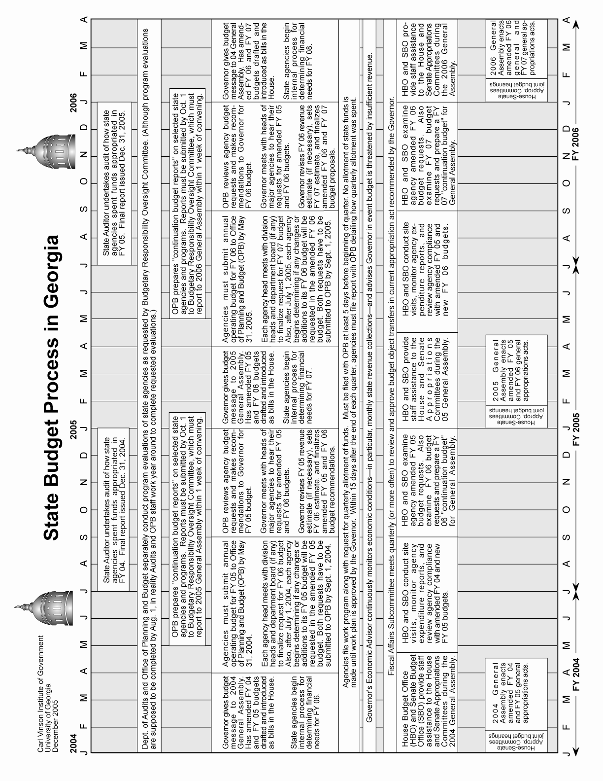

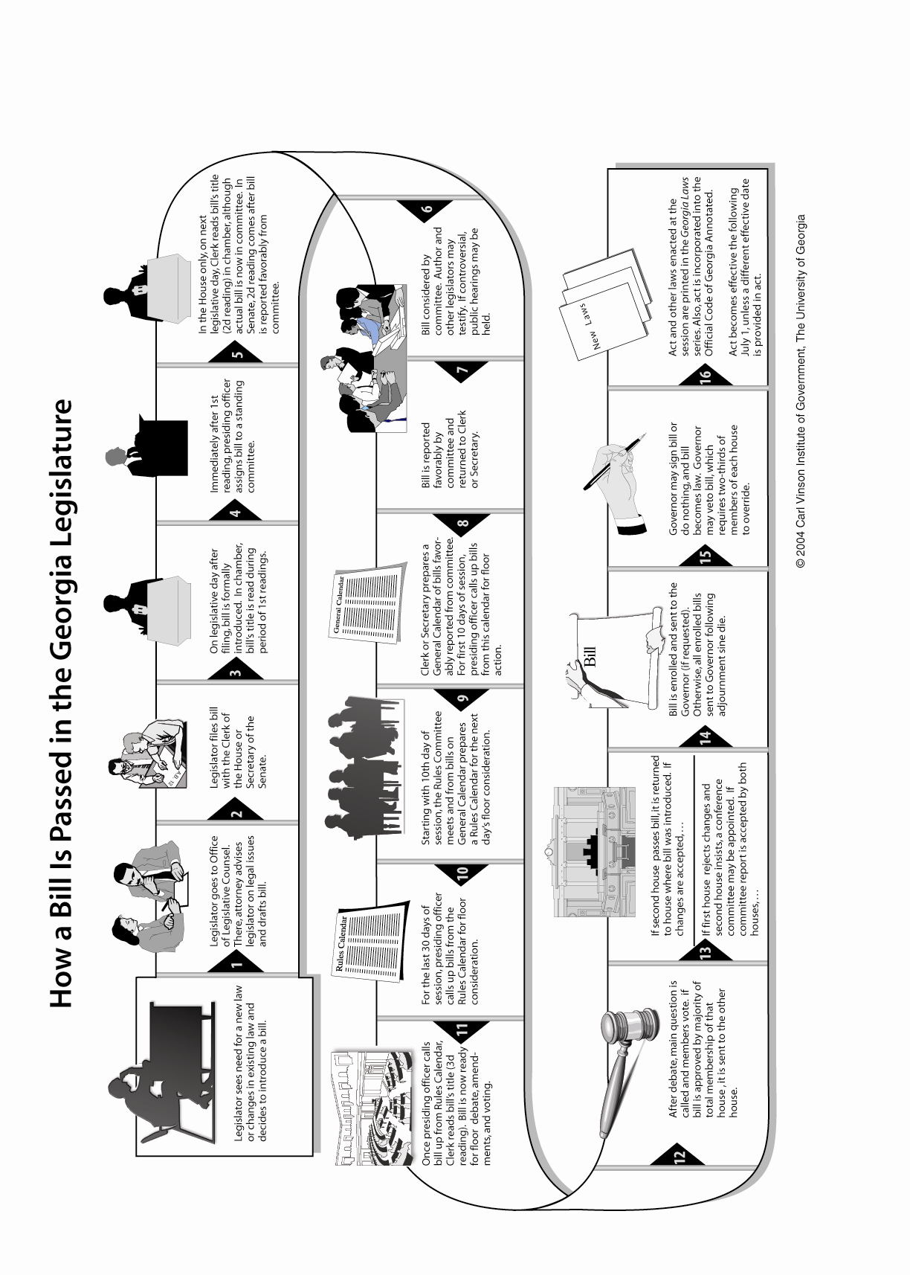
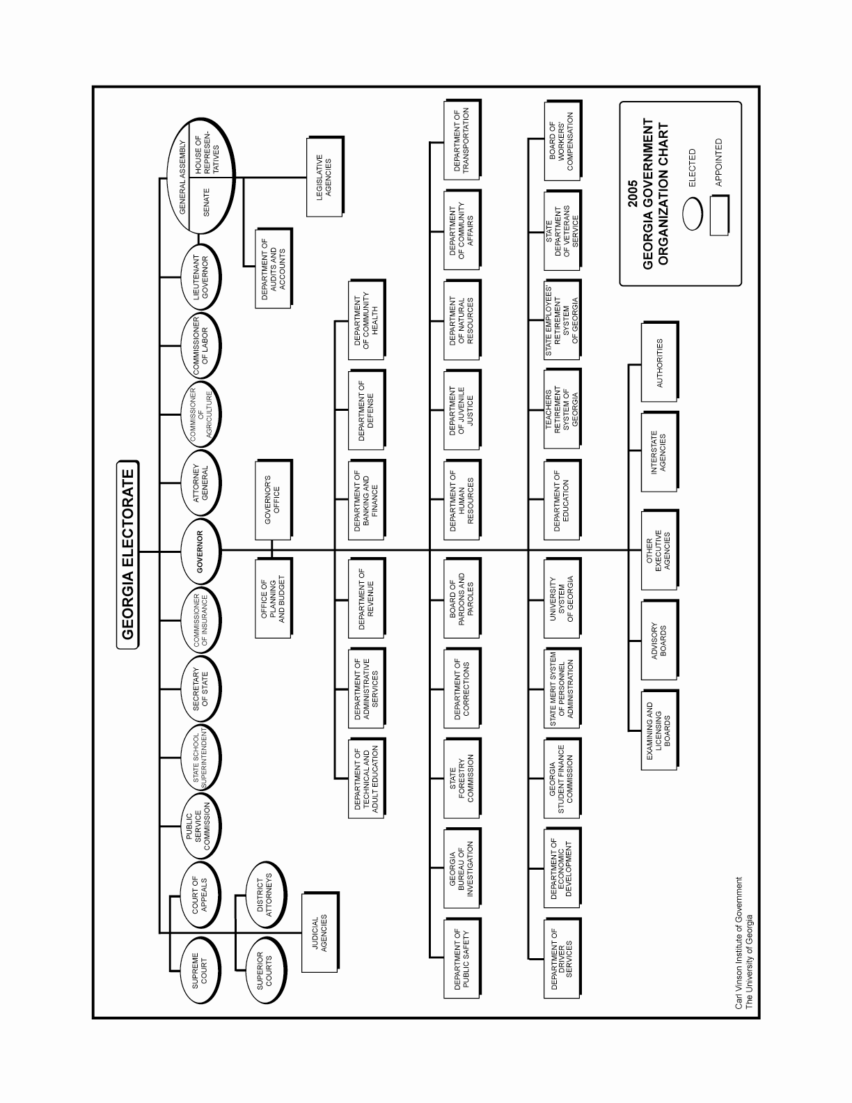
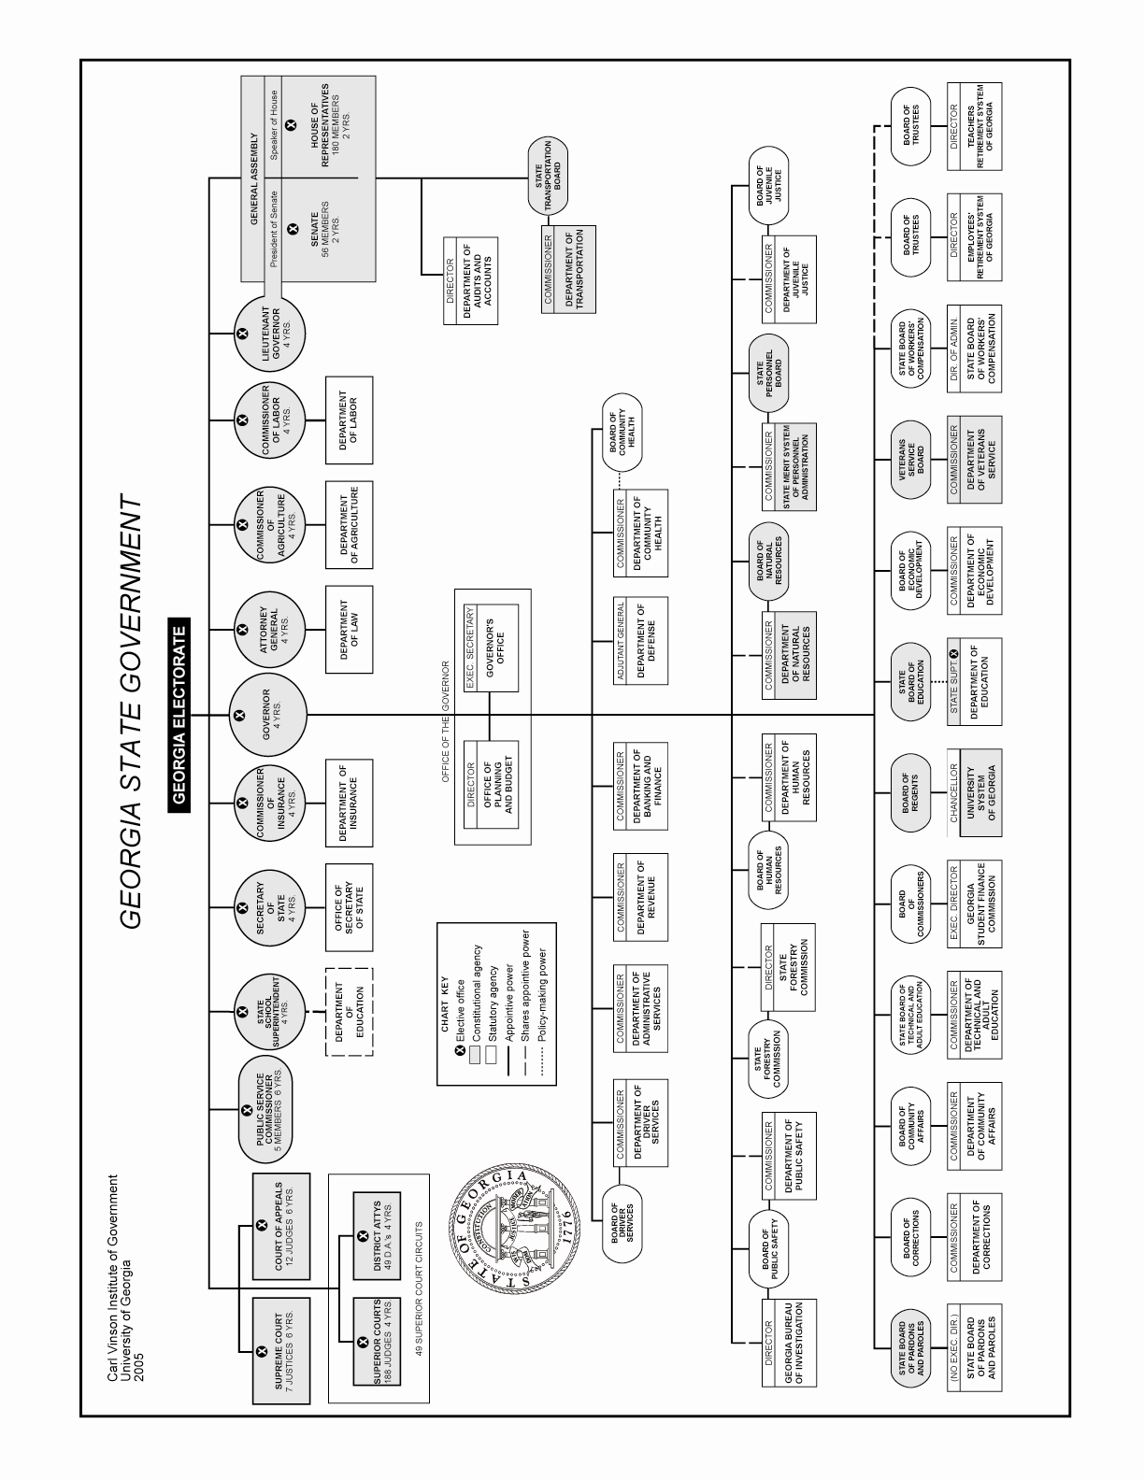
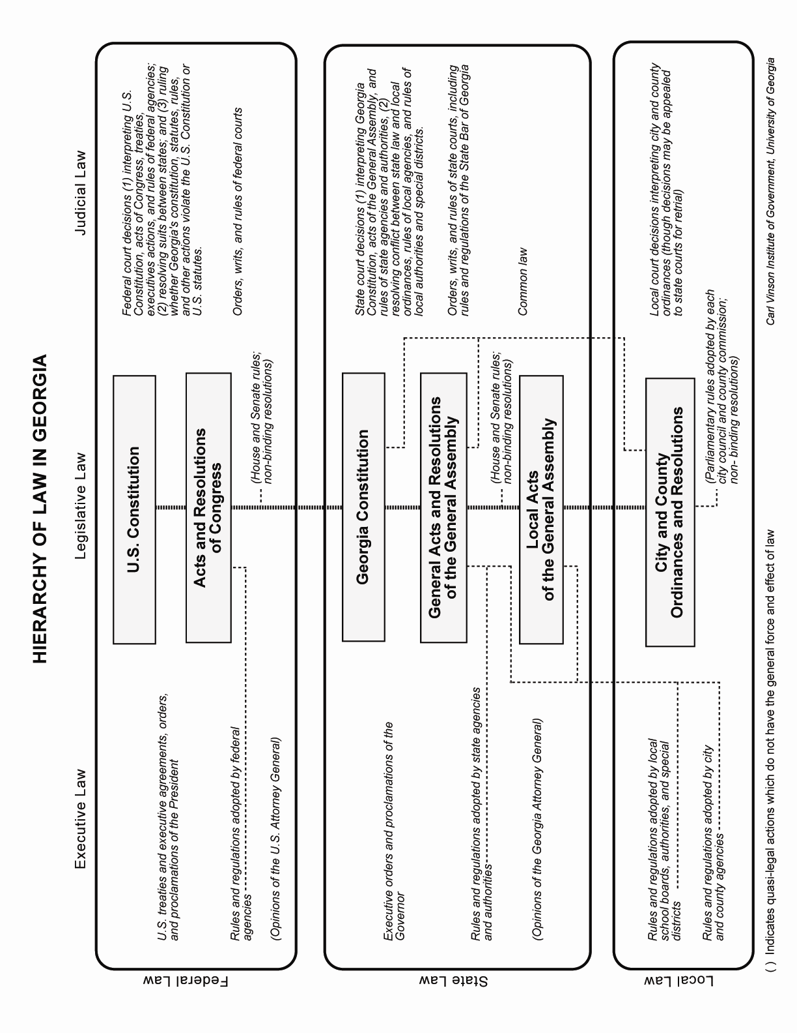

GEORGIA BOYS STATE GOVERNMENT

Section II

Georgia Boys State Government
Governments and governmental procedures in Georgia Boys State are patterned as closely as possible after those of the actual government of Georgia. Necessarily, however, there are some omissions and modifications.

City and County Alignments
The set-up of cities and counties in Georgia Boys State is listed below. The counties are named for four great Americans, and the cities are named for famous Georgians (Hugh Dorsey, Walter F. George, John B. Gordon, Henry W. Grady, Button Gwinnett, Lyman Hall, Joel Chandler Harris, Sidney Lanier, Crawford W. Long, James Edward Oglethorpe, Richard B. Russell, Hoke Smith, Alexander Stephens, Eugene Talmadge, Robert Toombs, and George Walton).

WASHINGTON ADAMS JEFFERSON MADISON

Dorsey City Gwinnett City Long City Stephens City

George City Hall City Oglethorpe City Talmadge City

Gordon City Harris City Russell City Toombs City

Grady City Lanier City Smith City Walton City

Nominations and Boys State Offices
The Georgia Boys State is composed of approximately 450 citizens; all assumed to be of voting age, and organized into city and counties (4 cities to each county). Upon registration, each citizen becomes a qualified voter and eligible to hold any office within the State or any of its sub-divisions.

Each citizen will be expected to hold an office, either elective or appointive. BUT NO CITIZEN MAY HOLD MORE THAN ONE ELECTIVE OFFICE AT THE SAME TIME, EXCEPT AS FOLLOWS: The holder of city or county party offices may in addition hold one other office. Service on a jury is not considered as holding an office, nor is service as a newspaper editor. However, if you try for an office and fail to win the nomination or election do not stop but start trying for another office.

NOTE: A city officer may run for a county and/or State office, if elected he shall immediately resign his city office. (Upon resignation of a city officer, the City election board will set up a special election to fill the vacancy or vacancies.)
To prevent confusion the holder of a county office is not (repeat NOT) permitted to neither seek a State nomination nor run for State office.

No one will force you to vote, but surely you will realize that it is a civic duty and an obligation of citizenship and also that it is the only way all citizens can participate in their business of government. All of us would fight to keep the right to vote, so let’s not fail to use it.

Citizens of Boys State who catch the real spirit of the undertaking – that of preparation for being dependable leaders and discerning followers when the day comes for them to operate the actual machines of Georgia’s government – will realize that the part played at Boys State by a deputy fire chief is fully as important as that of the citizen who is chosen Governor.

The regular nominating procedure of the political parties in Georgia is to select party candidates by the primary ballot; but time will not permit the use of the system in all elections at Georgia Boys State. Therefore, Boys State citizens will meet in party caucus or convention to select the party’s candidates for city and county office. Each citizen will be considered a delegate to the convention of his party in his city and county as well as in the State as a whole.

Each citizen when he registered was arbitrarily assigned to one of the two parties, Nationalist or Federalist. These labels were merely for convenience and have no other significance. Ordinarily, if you have chosen your party of your own free will, you would expect to support that party’s candidates in the general election; but in Boys State, since you were arbitrarily assigned to a party, the party affiliation is to be strictly adhered to only during the process of nominating candidates. After candidates for office have been nominated, party identities may be disregarded until the next party meeting is held.

The secret ballot will be used for all general elections in Boys State and each citizen may vote for the candidate he regards as best fitted for the office. In the event of a tie for any office, a runoff is ordinarily held, but in Boys State the tie will be broken by tossing a coin.

Campaigns
If you are a candidate for any office, it is your duty to campaign as vigorously as you possibly can. Conduct a fearless and clean campaign. Be a credit to your party. Urge your friends to campaign for you. For campaign supplies consult your counselor.

If you are a candidate, do not hesitate to call upon your friends to support you, and do not hesitate to make a speech in your own behalf whenever the occasion permits.

Consult your counselors whenever you deem it advisable. They are there to assist you in any manner you desire.

The more work you put into your campaign, the greater the rewards will be. You and your friends should seriously measure your particular qualifications for the office you seek. Make up your mind to develop a following. Campaign hard! Go into an election to win! But remember also that if you lose, the citizens have found something in your opponent or his party principles that they like better. Do something constructive about it. Don’t condemn the world because you have lost. You must remember that at the conclusion of the general election only one candidate for each office in each city, county and state will be elected.

Therefore, one candidate for each such office will be defeated. If you are a successful candidate, immediately prepare yourself for taking over the duties of you particular office. Carry out those duties in the same fearless, sincere and honest manner pledged during your campaign. Select your appointees with care. If you happen to be one of the defeated candidates, remember – the citizens have spoken their choice. Do not make your defeat personal, but immediately do what you can as a good citizen to help the administration in office conduct the public business to the best interest of all the citizens. You must be able to win or lose alike. That’s true American Citizenship.

Elections
The election board of each city will manage the elections. Citizens will always vote in their respective area designated by their County Coordinator.

No member of a city election board can serve as such at any election if he is a candidate in such election, but he may suspend his election board membership to run in any election; the vacancy so created will be filled temporarily in the same manner as he was originally chose.

PRIMARY ELECTION: The Primary Election for both political parties are conducted simultaneously. At the Primary Election each citizen votes for the best nominees for his party only.

GENERAL ELECTION: At the General Election, the nominees of each party oppose the nominees of the other party. Each citizen votes for the best nominee without regard to party affiliation.

GEORGIA BOYS STATE CITY GOVERNMENT

Section III

City Conventions, Elections and Government

City Conventions
The members of the Federalist Party will meet as a convention of their party under the supervision of their city counselor. The Nationalist will observe. The order of business shall be:

1. Election of a Chairman. The chairman will preside over the convention and act as general campaign chairman for the party's candidates. The Party Chairman will also be the city’s representative to the State Party Executive Committee.
2. Election of a Secretary. The secretary will keep minutes of the party convention. The City Party Secretary will also act as a member of the city election board.
3. Nomination for the offices listed below. There should be no limit to the number of candidates and voting will take place by show of hands.
4. Report of results of the Convention to General Headquarters on the form provided.

After the Federalist party has completed its convention, the Nationalist party will conduct their convention while the Federalist observe.

City Elected Officials

Mayor
Recorder
Five Councilmen

As soon as the conventions adjourn, the campaigns will begin. Each party chairman will have an equal amount of time apportion among his party’s candidates. In case of dispute, the Counselor will act as moderator.

After the city conventions adjourn, the two city party secretaries of each city will then choose a third citizen of their city to act with them as a city election board. The three members of the election board of each city will report to General Headquarters 15 minutes prior to an election for instructions on how to conduct the election and to receive the ballots, ballot boxes and registration list, tally sheets and other election supplies. If one of the members of the election board is running for an office during a specific election, he will designate a citizen to take his place on the board for that election.

City Organization
After being sworn in, the Mayor will appoint the 4 city appointive officers as indicated in the "Functions and Duties of City Officers" section of this manual. The Mayor will report his appointees on the form provided.

CITY COUNCIL MEETINGS: When City Council meets it should make its appointments of the city officers and certify them on forms provided. At the same time, city ordinances should be reviewed and adopted with modifications as deemed advisable by the body as well as disposing of any other business that comes before the council.

Functions and Duties of City Officers
City officials elected in each city are Mayor, Recorder, and five Councilmen.

The Mayor-Council type of city government, since it predominates in Georgia, is used in your cities.

From their election on Monday until the county governments begin to function, all authority will rest in the hands of the city officers. As county officers are elected, they will take over certain functions theretofore administered by city officers alone. In all instances of overlapping jurisdiction, the county officers’ authority is superior to that of city officers.

Following is an outline of the duties of each officer:

MAYOR
The Mayor:
1. Presides at all meetings of the city council.
2. He appoints the following assistants: Chief of Police, Fire Chief, Health Commissioner, and Superintendent of Parks. He may (for good cause) remove these assistants from office at will and replace them.
3. Supervises the work of all appointive assistants.
4. Promulgates city ordinances by publication in the city newspaper or by posting in a prominent place in the city. He may veto any ordinance passed by the city council if he does so within 24 hours from the time the ordinance was passed, otherwise it is valid without his signature. An ordinance may be passed over the Mayor’s veto by a two-thirds majority of the council.

CITY COUNCIL
Five city councilmen are elected in each city. The functions of the council are:
1. To act as the city’s legislative body.
2. To appoint the City Attorney and the City Clerk-Treasurer.
3. To hear reports of the activities of the Mayor and other elective officers.

RECORDER
The Recorder’s Court has the following jurisdiction: To try infraction of city ordinances, and to bind over to the Grand Jury in other cases. The Recorder’s duties are:
1. To organize his court, fix a regular place and time for holding court, and require any peace officer to enforce his decision.
2. To hear and render a decision with regard to all cases within his jurisdiction which are brought before him.

APPOINTIVE CITY OFFICERS

CITY ATTORNEY
This officer, chosen by City Council, must:
1. Give legal advice to the Mayor and other officers of the municipal government.
2. Defend the city against law suites and represent the city when the city is plaintiff before any court.
3. When required, act as prosecutor for violations of city ordinances.

CITY CLERK AND TREASURER
This officer, chosen by City Council, is the official record keeper of the city and the official custodian of the city’s property. He must:
1. Keep records of council meetings, including votes on ordinances introduced and adopted.
2. Act as secretary to the City Counselor.
3. Requisition and secure necessary property, supplies, etc. from the Supply Office. Such supplies are issued only upon the order of the Mayor countersigned by the City Counselor.
4. Keep a record of all articles to be returned.
5. Act as City Postmaster and distribute to the addressee all mail for citizens of his city.

POLICE CHIEF
This officer is chosen by the Mayor. His duties are:
1. To act as the principal agent for law enforcement in the city, seeing that ordinances are observed and order maintained.
2. To arrest and place in the city detention area any person charged with the violation of an ordinance.
3. To guard the city area from pilfering and disturbance.
4. To act as bailiff in the Recorder’s Court.
5. To cooperate with the State Department of Public Safety and the county sheriff in enforcing the peace.
6. Make bed check each night, sign report and immediately deliver it to the County Sheriff at County Headquarters.

FIRE CHIEF
This officer is chosen by the Mayor. His duties are:
1. To inspect the area of his city for fire hazards, and report any found.
2. To see that no citizen smokes in bed and that no cigarette stub is disposed of except by putting it into an ashtray or ashcan.
3. To check fire-fighting equipment in his area, such as extinguishers, etc.
4. To organize a volunteer fire department of ten citizens for emergency service.
5. To turn off the lights promptly at the sounding of taps each night unless otherwise directed by the City Counselor.

HEALTH COMMISSIONER
This officer is chosen by the Mayor. His duties are:
1. To report to the City Counselor the names of all citizens who are sick; to escort them to the infirmary when necessary.
2. To make daily inspection of the sanitary conditions of the area, including shower baths, toilets, drains, etc.
3. To have charge of morning clean-up of quarters. (He may file a complaint and cause arrest of citizen failing to cooperate with sanitary measures).

SUPERINTENDENT OF PARKS
This official, chosen by the Mayor should:
1. Promote participation by the citizens of his city in athletic and other recreational programs.
2. Regulate the use of and be responsible for sports equipment assigned to his city.
3. Check with the party captain of each team and report to City Counselor when each team leaves for the proper area for recreation period on time, or the cause of any delay.
4. Cooperate in every possible way with the Supervisor of Recreation.

City Courts in Session
Recorder's Courts
Each City Recorder will hold court in the City Headquarters for the purpose of trying all cases brought before the court for violation of city ordinances. This trial will be before the Recorder only, as no jury will be used for city courts. The City Attorney will represent the city and act as prosecutor. The citizen charged with the violation (the defendant) will be brought before the court by the Chief of Police. If the defendant desires, he may represent himself, have another citizen to act as his attorney or have the court appoint an attorney to act in the defendant’s behalf. At the conclusion of each trial the Recorder will declare the defendant guilty or not guilty and pronounce restrictions.

Georgia Boys State City Charter
(In effect in each city of Boys State until amended by the Boys State General Assembly.)

An act to incorporate the City of . . . . . . . . . . . . . . . . , in the County of . . . . . . . . . . . . . . . . . ., Georgia Boys State; to define its territorial limits; to provide all ordinances, rules, regulations and resolutions; to declare and constitute the rights and powers of said city; to provide the rights, powers, duties and qualifications of all officers and the manner of their election or appointment; to provide for a Recorder’s Court, the trial and punishment therein of all offenders against the laws and ordinances of said city, and appeal therefrom; to provide for the assessment, levy and collection of an ad valorem tax and all other taxes; to provide for all matters and things necessary and proper or incident to a municipal corporation; to grant certain powers and privileges to the same; and for other purposes.

Section 1. Be it enacted by the General Assembly of Georgia Boys State, and it is hereby enacted by the authority of the same, that the City of . . . . . . . . . . . . . . . . , in the County of . . . . . . . . . . . . . . . . , Georgia Boys State, be and the same is hereby incorporated as city, under the name of the City of . . . . . . . . . . . . . . . . , with perpetual succession.

Section 2. Be it further enacted by the authority aforesaid, that the corporate powers of said city shall be vested in a mayor and five councilmen, and by the name of . . . . . . . . . . . . . . . . city, said, city may sue and be sued, plead and be impleaded, and exercise all the corporate powers that may be necessary.

Section 3. Be it further enacted by the authority aforesaid, that on the second Monday of June in each year an election shall be held in the council chamber of said city for a mayor, recorder and five councilmen, who shall hold their offices for one year, and until their successors are elected and qualified. The city officers shall take office immediately upon election. No person shall vote or be eligible to the office of Mayor, Recorder, or Councilman, who is not qualified to vote for members of the General Assembly of this State. Such election or elections shall be held and conducted in the same manner as election for officers in the State, and the certificate of the election managers shall be sufficient authority to the persons elected to enter upon the discharge of the duties of the offices to which they have been elected. In the event that the office of Mayor, Recorder, or any member of the Board of Councilmen shall become vacant, by death, resignation, removal or other cause, the Mayor, or in case his seat is vacant, the majority of the councilmen may fill said vacancy by appointment until the next regular election.

Section 4. Be it further enacted by the authority aforesaid, that before entering on the discharge of their duties, the Mayor, Recorder, and Councilmen shall subscribe to the following oath, which may be administered by any person authorized by the laws of Georgia to administer oaths: “I do solemnly swear that I will faithfully discharge all the duties devolving on me as (Mayor, or Recorder, or Councilman as the case may be) of the City of . . . . . . . . . . . . . . . . , County of . . . . . . . . . . . . . . . . , Georgia Boys State, according to the best of my ability and understanding, so help me God.”

Section 5. Be it further enacted by the authority aforesaid, that the Mayor and Councilmen shall have power and authority to pass all laws and ordinances that they may deem necessary for the government of said city and the protection of property of the citizens of said city, provided that they be not repugnant to the Constitution and laws this State and of the United States.

Section 6. Be it further enacted by the authority aforesaid, that the Mayor and Councilmen shall have the power and authority to levy and collect a tax not exceeding three dollars per Boys State Year, upon all property, both real and personal, within the corporate limits of said city, and the same may be enforced by execution issued by the Clerk of the City of . . . . . . . . . . . . . . . . and by sale of property, as in sales of property liable for State and County taxes; all levies of tax execution to be made by the marshal or chief of police and to be conducted as sales by the sheriffs in case of levy of tax executions. They shall also have power to require all persons within said city who are subject to road duty under the laws of this State to work on the streets of said city, or they may prescribe a commutation tax which may be paid in lieu of work upon the streets, provided, however, the officials of said city need not levy and collect any taxes at all, if in their discretion no taxes are needed.

Section 7. Be it enacted by the authority aforesaid, that the Mayor of said city, and in his absence the Mayor pro tempore, who shall be elected by the councilmen from their own number, shall be the chief executive officer of said city, he shall see that the ordinances, by-laws, rules and orders of the council are faithfully executed; he shall have control of the marshal or chief of police of said city, and may appoint special police whenever he may deem it necessary, and it shall be his duty especially to see that the peace and good order of the city is preserved, and that persons and property therein are protected, and to this end he may cause the arrest and detention of all riotous and disorderly persons of said city, he shall have the power to issue executions of all fines, penalties and costs imposed by him, or he may require the immediate payment thereof, and in default of immediate payment, he may restrict the offender.

Section 8. Be it enacted by the authority aforesaid that it shall be the duty of the Recorder to preside at the City Court known as the Mayor’s Court with full and ample authority to try and dispose of all cases within the jurisdiction of the mayor’s court as the Mayor has under the provisions of this charter.

Section 9. Be it enacted by the authority aforesaid that said Mayor and said Recorder shall be to all intents and purposes Justices of the Peace, so far as to enable them to issue warrants for offenses committed within the corporate limits of said city, and restrict offenders for their appearance at the next Superior Court of . . . . . . . . . . . . . . . . County.

Section 10. Be it enacted by the authority aforesaid, that in said Mayor’s Court, the Mayor, or person presiding for said Mayor, when any persons or person shall be convicted of the violation of any of the laws or ordinances of said city, may restrict said person for a period not to exceed one day.

Section 11. Be it enacted by the authority aforesaid that the City Council of said City shall appoint a city attorney for said city and also a city clerk, who shall be ex-officio treasurer of the said city.

Section 12. Be it enacted by the authority aforesaid, that the Mayor of said city may appoint a fire Chief of said city, a health commissioner, a superintendent of parks, a chief of police, and such other police officers as may be necessary.

Section 13. Be it enacted by the authority aforesaid, that the Mayor, Councilmen, Clerk and Treasurer of said city shall not receive any compensation for their services, and the Recorder or police officer or officers of said city may be given as compensation, such portion of fines collected by said City as the Mayor and Councilmen may think proper.

Section 14. Be it enacted by the authority aforesaid, that any person convicted of any offense in the Mayor’s Court of said city may carry his case to the Superior Court of . . . . . . . . . . . . . . . . County, by writ or certiorari, in the same manner as cases are carried or appealed from the justice court to Superior Court by writ of certiorari.

Section 15. Be it enacted by the authority aforesaid, that the authority to carry out and effectuate by ordinance each and every power and right granted to the city of . . . . . . . . . . . . . . . . by this act, is hereby expressly conferred on the Mayor and Councilmen of said city; and said Mayor and City Council shall have generally the powers and authority to make and pass such rules, by-laws, and ordinances as shall appear to them needful or requisite for preserving or promoting the peace, health, good order and welfare of said city and its inhabitants.

Section 16. Be it enacted b the authority aforesaid, that any person or persons shall be required to reside within the limits of said city in order to be eligible to hold any office or position in said city. Only persons residing within the limits of said city shall be entitled to vote in the city elections.

Section 17. Be it further enacted by the authority aforesaid, that all laws and parts of laws in conflict with the provisions of this Act are hereby repealed and this Act and charter shall become effective immediately upon its passage by the General Assembly and the approval of the Governor.

ORDINANCES OF CITIES

The following ordinances are in effect in each city of Georgia Boys State at the time of the formation of the city governments. These ordinances may be added to, repealed or modified by the City Councils of the various cities.

SEC. 1. Recorder's Court. Any person who is charged with an offense against any of the ordinances of the city of ___________________________ shall be informed of the accusation by having a written warrant served on him, outlining the nature of the offense of which he is accused; shall have compulsory process for obtaining witnesses in his behalf; shall have a speedy trial before the Recorder or, in his absence, the Mayor, Mayor pro tempore, or a member of the General Council; shall be confronted with the witnesses against him, and have the privilege of cross-examination, as in the Superior Courts of the State of Georgia. The same rules as to examination of witnesses and the evidence adduced as obtained in said courts, as far as they are applicable to examining courts, shall be applicable to cases before the Recorder's Court. The party accused shall have the privilege of defending himself, by counsel or by himself, or both, as to him shall seem proper. No one shall be condemned, fined or punished without the opportunity of being heard in his own defense.

SEC. 2. The Summons. It shall be the duty of the City Clerk in all cases where complaint is made on information given of a violation of any of the laws and ordinances of said City (whether the party be restricted or not) to issue a summons directed to the accused, requiring said offender to appear before the Recorder's Court, to answer said charge, which summons shall state the offense, the time and place of trial, bear teste in the name of the Mayor, be signed officially by the Clerk, and directed for execution to the Chief or other officer or member of the police force, who shall execute the same by serving a copy upon the accused, or leaving it at his place of residence.

SEC. 3. Recorder's Court Rules. The Recorder's Court shall be controlled by the rules of the Superior Courts, as far as they are applicable to the Recorder's Courts, and a sound construction of the charter and ordinances of the City.

SEC. 4. Punishment of Offenders. All offenders against the ordinances and laws of said City shall be tried by the Recorder's Court, and said Court may impose such punishment as is provided by the laws and ordinances of said City for the offense of which said offenders may be found guilty.

SEC. 5. Contempt of Court. Any person who, during the sitting of the Recorder's Court, or during a session of the City Council, shall be guilty of Contempt of Court, or of Council, or refuses to abide by any sentence or order of said Court or Council aforesaid, shall be fined in a sum not exceeding one
dollar and costs, or restrictions, or both, as shall seem expedient or proper under the circumstances. *

SEC. 6. Disorderly Conduct. Any person who shall, within the corporate limits of the City of ______________________, be accused of quarreling, or of using obscene, vulgar or profane language, or of malicious mischief, or otherwise act in a rude or disorderly manner shall, on conviction be guilty of a misdemeanor and be sentenced to pay a fine of not exceeding one dollar.*

SEC. 7. Spitting or Throwing Litter on Floors. It shall be a Misdemeanor for anyone to spit or to throw or permit the accumulation of any hulls, peelings, matches, papers, cigarette stubs or other litter upon the sidewalks or streets or upon the floors of the rooms of this City. Anyone violating any of the provisions of this section shall, on conviction before the Recorder's Court, and in the Court's discretion, be fined not more than one dollar.*

SEC. 8. Disturbing Beds. It shall be unlawful for any citizen to disturb the bed of any other person without that person's permission. Any citizen violating this ordinance shall, on conviction thereof, for each offense be fined in a sum not exceeding two dollars.*

SEC. 9. Noise at Night. Any person who shall make any noise after lights out calculated to disturb the public peace, or to annoy any of the citizens, shall be fined not exceeding one dollar. *

SEC. 10. Arrest of Offenders. The police shall arrest and hold under bond any offender against the laws and ordinances of this City, where in their judgment such action is necessary to secure said offender's appearance before the Court to answer for his offense, or preserve the peace of the City.

SEC. 11. Violators of State Laws. Any person who shall commit a violation of the laws of this State, shall be arrested and held by any peace officer, then taken before a proper judicial officer for a preliminary investigation and hearing.

SEC. 12. Bail. In all cases of violation of City ordinances, the person accused shall be admitted to bail and the amount of the bond shall be named by the Chief of Police, or in his absence, by the City Clerk. At a hearing the Recorder (or Mayor) may determine that the offense charged is a violation of a state law. Then it shall be his official duty to set the bond for the accused's appearance before the Superior Court.
*Any person failing to pay a fine shall be brought before the City Counselor by the City Recorder.

GEORGIA BOYS STATE

COUNTY GOVERNMENT

Section IV

County Conventions Elections and Government

County Conventions
If space permits, the Federalist and Nationalist will hold their conventions simultaneously. If space is not available, the members of the Federalist party will meet as a convention of their party and the Nationalist will observe. Then at the completion of the Federalist convention, the Nationalist will hold their convention. In either case, the order of business shall be:

1. Election of a Chairman. The chairman will preside over the convention and act as general campaign chairman for the party's candidates.
2. Election of a Secretary. The secretary will keep minutes of the party convention.
3. Nomination for the offices listed below. There should be no limit to the number of candidates and voting will take place by show of hands.
4. Report of results of the Convention to General Headquarters on the form provided.

County Elected Officials
Superior Court Judge
Superior Court Clerk
District Attorney
Judge of Probate
Sheriff
Three County Commissioners
Four State Senators
Eight State Representatives

As soon as the conventions adjourn, the campaigns will begin. Each party chairman will have an equal amount of time apportion among his party’s candidates. In case of dispute, the Counselor will act as moderator.

County Organization
County Commissioners will first elect a Chairman from their own number and a Clerk and County Attorney from outside their own number. These 3 names should be reported to General Headquarters on the form provided immediately following the meeting.

Functions and Duties of County Officers
Your elective county officers are as follows: Superior Court Judge, Judge of Probate, Clerk of Superior Court, District Attorney, Sheriff, and three County Commissioners.
The board-of-commissioners type of county government, which predominates in Georgia, is used in your counties. However, your General Assembly may at any time change the number or method of selection of county commissioners or the type of county government without referring the question to the citizens of the county.

The duties of the county officers are as follows:

SUPERIOR COURT JUDGE
In your State each county will be considered a Superior Court Circuit, and the Judge will have jurisdiction in all cases involving the violation of State laws and such civil suits as may be brought with the following duties:
1. To organize the court, fix a regular time and place for holding same, see that order is maintained while court is in session (using, if necessary, the power to punish for contempt of court) and require any county or city police officer to enforce the Court’s decisions.
2. To see that the docket and calendar of this Court are properly kept.
3. To hear and render a decision with regard to all cases within the jurisdiction of this Court which are brought before it.

JUDGE OF PROBATE
This official must:
1. Keep record of all persons in each county for the county counselor.
2. Give clerical assistance to the County Counselor when needed.

CLERK OF THE SUPERIOR COURT
This official must:
1. Keep record of all suits filed in the Superior Court and all proceedings and orders of the Court, including a summary of all testimony.
2. He will certify the record of all trials to the Appellate Court in all cases that are appealed.

DISTRICT ATTORNEY
It is this officer’s duty to act as the prosecutor of all citizens charged with violating the State laws.

SHERIFF
This official has the following duties:
1. He is the law enforcement officer of the county and state government.
2. He is the County Counselor’s right-hand man in maintaining order and will assist with the nightly bed check. He will receive the written report of bed check each night from the Chief of Police of each City in his County. When all reports are received each night he will deliver the consolidated report to Boys State Headquarters.
3. He is the official jailer for those charged with or convicted of crimes. In case a citizen is restricted as a penalty, he will supervise the carrying out of the restrictions.
4. He will appoint two deputies, one to serve as bailiff of the Superior Court and the other as jailer. He may relieve these deputies at any time.
5. He will assist the Counselor in supervising the conduct and bearing of the citizens of his county in court, in general assemblies, at mess, or on the athletic field.
6. Although the Sheriff’ responsibilities are chiefly to the citizens of a single county, the sheriff has the authority to arrest citizens of other counties when they are violating state laws.

BOARD OF COUNTY COMMISSIONERS
This Board must:
1. Consider legislation dealing with problems of interest to their county and pass ordinances regulating the activities of the county’s citizens.
2. Hear reports of activities of elective and appointive officers.
- Appoint a County Attorney to represent the county in litigation and legal transactions, and a Clerk of the Board to keep minutes of their meetings.

County Courts in Session
Superior Courts
The Superior Courts of each county will hold session in the County Headquarters for the purpose of trying all cases wherein there are alleged violation of the laws of Boys State. (All citizens of the county will be in attendance.) The Superior Court Judge will be in charge of the court and will organize same. A jury (consisting of 12 citizens) will be impaneled at the beginning of each session and will serve throughout the session, as time will not permit the selection of a jury for each case. The District Attorney will act as prosecutor and the defendant may have any citizen he desires to represent him as his attorney. If he has not appointed an attorney, the Judge will appoint one. The defendant will be brought before the court by the County Sheriff or Deputy. When all evidence has been presented and the appointing attorneys have given their summation, the Judge will charge the jury. After deliberation the jury will announce its verdict, guilty or not guilty. The Judge will then pronounce restrictions. If the defendant believes that the court has committed error in finding him guilty, he may appeal to the Court of Appeals and/or the Supreme Court.

GEORGIA BOYS STATE CONVENTIONS/ELECTIONS/GOVERNMENT

Section V

State Conventions, Elections and Government

State Party Organization

State Executive Committee
The Party Chairman from each city makes up the State Central Party Committee. This committee will meet and elect one of its members as State Party Chairman and one of its members as State Party Secretary. This committee has the duty to see that the party it represents has at least two candidates for each office on the state primary election ballot. It also coordinates all of the campaign plans of each candidate in the party and oversees all arrangements for the party rallies.

From this group the Party Chairman will appoint equal members to the following committees:

Platform Committee
The ideas and aims of the party will be developed in the meetings of the platform committee. All possible issues should be discussed during the party meetings for recommendation to this committee. The committee will then draft an official party platform subject to ratification by the entire party membership. This committee is molding policies of Georgia Boys State and its citizens, and the eyes of the State of Georgia are on these platforms.

Legislative Committee
This committee shall prepare at least three bills supporting the party platform to be introduced in the House and Senate. These proposed measures are to be prepared prior to the convening of the Legislature.

Campaign Committee
This committee shall plan the entire campaign program and coordinate all of the candidates' efforts during the rally.

State Conventions
All citizens of Boys State who are members of the same party will meet in a State Party Convention, with the State Party Chairman in charge. The State Party Chairman and State Party Secretary will not be eligible to run for a State Office.

The elective offices to be filled at the state elections are as follows:
Governor
Lieutenant Governor
Secretary of State
Attorney General
Commissioner of Labor
Commissioner of Insurance
Commissioner of Agriculture
State Superintendent of Schools
Public Service Commission (5 members)
Justices of the Supreme Court (7 members)
Judges of the Court of Appeals (12 members)

The State Executive Committee shall approve the method and time period for filing for State office. To file, it is necessary to obtain an official Letter of Intent, fill in the requested information, have a counselor sign the form, and file the Letter of Intent with General Headquarters prior to the expiration of the filing period. Once a Letter of Intent has been filed, it is official and cannot be changed. A list of who has filed a letter of intent will be posted at General Headquarters.

The State Convention shall fix the date and time of qualifying. In lieu of a qualifying fee, the State Convention will fix the numbers of qualifying coupons necessary for each candidate to obtain to qualify. Once a candidate has qualified, his name will be placed on the primary election ballot. Qualifying coupons shall be issued by the Counselors to the citizens at the appropriate time.

A citizen can only give qualifying coupons for nominees of his own particular political party. A citizen may endorse only one candidate for each office to be filled, except for Justice of the Supreme Court (in that case each citizen may endorse seven individual nominees); Member of the Public Service Commission (five individual nominees); Judges of the Court of Appeals (nine individual nominees) of his party only.

The party chairman and secretary together with all other members of the State Executive Committee not running for the primary election are charged with the duty of scrutinizing carefully and tabulating and certifying to Boys State Director, the qualifying coupons collected prior to the expiration of qualifying time or the candidate’s name will not be included on the ballot. The party secretary will have a list of all who declared their intent to run for office.

The Party Convention Report may be obtained from General Headquarters. This form should be returned to Headquarters as soon as possible following the State Convention.

State Organization
After the results of the State General Elections are announced, all newly elected officials will meet with the Legislative Coordinator. Organization of the State Government will then proceed.

Legislative Branch

Caucus

After election, the new members of the Senate and House of Representatives will meet with the legislative counselor who will brief the members. Shortly thereafter and prior to the first scheduled session of the two houses, the Federalist House members, Nationalist House members, Federalist Senate members, and the Nationalist Senate members will caucus. Each caucus will decide their nomination for their respective house officers and their selections for committee members. The nominees for Speaker, Speaker pro tempore, and President pro tempore should be strong speakers with knowledge of parliamentary procedure and meeting conduct. The majority party will also select a Majority Floor Leader and committee chairmen; the minority party will select a Minority Floor Leader.

Each party caucus should also select their preferred appointments for Clerk, Doorkeeper and Messenger. These members are appointed from outside the membership of the House and Senate. Each party will also insure that their selectees for Clerk, Doorkeeper and Messenger will agree to serve in these capacities if appointed by the Speaker (for the House) and the President pro tempore (for the Senate) that is elected during the first legislative session.

First Legislative Session

At the first meeting of the two houses, the counselor assigned will act as Speaker (President) and will first present the Rules for adoption. After adoption, nomination will be opened for officers. At this time the Majority Floor Leader and the Minority Floor Leader will nominate their party's candidates. Other nominations may also be made, however, normally there will be the only two candidates for each office (the ones chosen during caucus and placed into nomination by the Majority and Minority Floor Leader). After the Speaker (President pro tempore) is elected he will take charge and complete the election of officers. After completion of the election of officers, the Speaker (President pro tempore) will appoint the Clerk, Doorkeeper and Messenger. At this point, business will continue as outlined in the Procedures – House of Representative and Senate.

The Boys State General Assembly will meet in joint sessions to hear the Boys State Governor’s address. At other times, the Senate and House will meet separately, the former to consider the Governor’s nominations to appointive State offices and both to consider legislation.

Executive Branch
The Governor-Elect will make the following appointments to be forwarded to the Senate for confirmation: Secretary to the Governor, Commissioner of the Department of Human Resources, Commissioner of the Department of Public Safety and 4 members of the State Board of Education (one from each county). In addition, the Governor will prepare his State of the State address for the inauguration evening. The Governor will also organize his office and staff to carry out the business of the State.

The Lieutenant Governor-Elect will assume his position as President of the Senate.

As soon as confirmation of appointees to the State Board of Education has occurred, the State School Superintendent will organize the Board of Education.

All other members of the Executive Branch will carry out their duties as outlined in this manual.

Judicial Branch
The Supreme Court and Court of Appeals will convene as needed to consider cases forwarded for their review or for other duties as assigned.

Functions and Duties of State Officers

Executive Branch
The executive officers who are elected at large by vote of all citizens of your state are the Governor, Lieutenant-Governor, Secretary of State, Attorney-General, Commissioner of Agriculture, Commissioner of Insurance, State School Superintendent, Commissioner of Labor, and 5 Public Service Commissioners. In addition, there are several appointive executive officers.

Following is a brief outline of the functions and duties of each State Official.

GOVERNOR
The Governor is the Chief Executive of your government, with the following functions and duties:
1. With the advice and consent of the Senate, appoint such executive assistants as may be provided by law (see below).
2. Be responsible for the proper supervision of appointive officials, with power to remove them at will.
3. Sign into law all bills passed by the General Assembly, or he may veto any or all legislation. The power of veto must be exercised and the legislation returned to the house of origin within 4 hours from the time it is presented for approval; otherwise the bill becomes a law without his signature. A bill vetoed by the governor may be enacted into law upon the vote of two-thirds of the membership of both houses of the General Assembly.
4. Address the joint session of the General Assembly.
5. Preside at graduation.

LIEUTENANT-GOVERNOR
This officer’s functions are:
1. To take the place of the Governor if the latter is ill or unable to serve.
2. To preside over the State Senate when not serving as Governor.
3. To assist the Governor when requested.

SECRETARY OF STATE
This official’s duties are:
1. To be Secretary of your State government and take charge of all records of Boys State.
2. To be the official custodian of the State archives.
3. To act as general clerical assistant to the Director.
4. Prepare a complete summary of Boys State legislation.

ATTORNEY-GENERAL
This official’s functions are as follows:
1. To be the legal adviser to all state officials and agencies.
2. To represent you State in all suits or legal actions where it is a party.
3. Upon request, or upon orders from the Governor, to assist Solicitors-General with the prosecution of citizens charged with violating the laws of the state.
4. To act as an assistant to the Director in connection with routine matters of discipline not brought before the courts.

COMMISSIONER OF INSURANCE
The duties of this officer are::
1. Act as custodian of all equipment belonging to your state.
2. To check up on all city, county and state officers who are responsible for equipment and supplies and see that all are in good condition and properly accounted for.
3. To act as State Fire Marshall, as State Building Inspector and supervise City Fire Chiefs
4. To act as the State Comptroller-General.

STATE SCHOOL SUPERINTENDENT
This official will:
1. Conduct, before the end of the week, an investigation among all citizens relative to their attitudes toward the program, seeking constructive suggestions as well as critical comments, and make a full report to the Director.
2. Act as a general assistant to the Supervisor of citizen activity in all matters affecting training policies.

COMMISSIONER OF AGRICULTURE
The duties of this officer are:
1. To make recommendations to the Governor and the General Assembly for regulations and legislation for a progressive agriculture program.
2. To supervise and direct the State Department of Agriculture.

COMMISSIONER OF LABOR
The duties of this officer are:
1. To make recommendations to the Governor and the General Assembly for regulations and legislation for the maximum employment of all citizens of Georgia Boys State, with the objective that each citizen receive from the Citizenship Program the most benefit from instruction and active participation.

PUBLIC SERVICE COMMISSION
The commission consists of five members elected at large. The candidate receiving the highest vote shall be Chairman of this Commission. This Commission shall recommend to the Governor and to the General Assembly a progressive public utility program.

APPOINTIVE OFFICERS of the EXECUTIVE BRANCH
Appointments in the executive branch of your State government are made by the Governor with the advice and consent of the Senate. The following appointments should be recommended by the Governor:

SECRETARY TO THE GOVERNOR: This is a personal appointment by the Governor. The duties involve considerable clerical work. The citizen appointed to this position should be a good penman and a fairly good typist and should be friendly with the Governor and know his plans and policies. He prepares and attests all Executive Orders, Commissions and Certificates issued by the Governor.

COMMISSIONER OF DEPARTMENT OF HUMAN RESOURCES: It is the officer’s duty to promote citizen morale in every possible way. Social activities are included in this field.

COMMISSIONER, DEPARTMENT OF PUBLIC SAFETY: This officer will have general supervision over all city and county law enforcement and will have final responsibility for keeping the peace and enforcing law and order.

STATE BOARD OF EDUCATION: One from each county. They work with the State School Superintendent.

Legislative Branch
Your General Assembly consists of two houses: (1) The Senate with four Senators from each county, and (2) The House of Representative with eight Representatives from each county. State legislators are state officers. To simplify your election, however, they are nominated at the county conventions and elected at the county elections.

The function of the legislature is to enact rules and regulations, called statutes, for the general control and welfare of the citizens of the state. The two branches – Senate and House of Representative – should act as a check on each other. Legislation to become effective must be passed by a majority of the elected members of each house and be approved by the Governor. Legislation which the Governor vetoes within 4 hours after it is presented for approval will not be effective unless re-passed by a two-thirds majority of the members elected to each house.

The offices of the Senate are: The offices of the House of Representatives are:
President (Lieutenant Governor) Speaker
President pro tempore Speaker pro tempore
Clerk Clerk
Messenger Messenger
Doorkeeper Doorkeeper

Judicial Branch
Seven Justices of the Supreme Court and twelve Judges of the Court of Appeals will be elected at large by vote of all citizens. The Justice receiving the largest number of votes will be the Chief Justice. The Judge receiving the largest number of votes will be the Chief Judge.

These Courts will have general appellate jurisdiction – that is, they will review decisions of superior courts in the event the unsuccessful party is dissatisfied therewith and applies for such review to the Supreme Court or Court of Appeals. The Appellate Courts will not hold a new trial but will review the records of the original trial and hear oral argument from both sides.

The members of each Appellate Court, that is the Supreme Court and the Court of Appeals, will choose from outside their own number a citizen to be Clerk and Ex-Officio Sheriff of each court. He will keep the records and docket and be the Court’s executive officer, serving its papers and keeping order while it is in session.

Parliamentary Procedure
The technique for controlling legislative procedure is best referred to as group leadership, because the legislator has the job of selling his ideas to the other people of his official group. But group leadership in a legislature differs greatly from certain other types of group leadership. A legislator has to do his own selling under a set of rules called parliamentary legislative procedure, or “rules of order.” If all members of a legislature got up at the same time and started selling their ideas, there world be chaos. A group cannot do anything without set or well-established rules properly enforced.

A legislator must know the rules for legislative procedure so that he may influence others on his proposals in accordance with these rules. However, one does not have to commit all these rules to memory to be effective.

The best system of rules for the conduct of group discussion and action is called parliamentary procedure, because their system of rules was involved by the British Parliament during its centuries of experience in operating the government of Great Britain.

These rules, slightly modified, were adopted by the Congress of the United States to govern its procedure. Then, in 1876, General Henry M. Robert simplified these rules so as to adapt them to the use of ordinary societies, and they have been generally accepted throughout the United States as the standard “rules of order” for group meetings.

Rules of Legislative procedure in force in the United States today are the product of a thousand years of legislative experience in England and America.

In fact, this set of rules for government of the Legislative Body is one of the greatest achievements of the English and American people with which every American should be familiar. It is such a great achievement that the other countries of the civilized world have adopted these rules for the use of their own legislative bodies. Unfortunately, few Americans know this magnificent set of rules even in part.

The purposes of “rules of procedure” are three in number. The first purpose is to provide an orderly way of doing things, just as in baseball. The rules make it clear who is to bat, who is to pitch, and who may catch it. The rules of promotion for a meeting tell who may make a motion, and when; who may discuss it, and when it is to be voted upon for adoption or rejection.

The second purpose is to protect the rights of the majority. Since the majority can always out-vote the minority, “rules of procedure” must guarantee to the minority the right to speak against the motion and to propose amendments to it. In effect, the minority (in America) says, “If you will first listen to our arguments against this motion, we will then be willing to accept the decision of the majority.” In a dictatorship, the minority have no rights at all.

The third purpose of “rules of procedure” is to insure reasonable prompt action. While the minority should be permitted to talk, they should not be permitted to talk forever. The majority has rights just the same as the minority, and one important majority right is the right to come to some definite decision after the minority has had their say.

Conduct in Meetings
In all sessions of any kind – city – county – or state – a member desiring to address the Chair shall rise and call out clearly, “Mr. Chairman.” He cannot speak until recognized by the Chairman.

The Chairman will indicate the person recognized by stating, “The Chair recognizes Mr. _________.” The person thus recognized is entitled to the floor.

The Chairman of the meeting shall declare any person “out of order” who fails to observe proper decorum.

In referring to other members when addressing the assembly, the person speaking must use an impersonal designation such as the “last speaker,” “The gentleman from Grady City,” or “The Distinguished gentleman from Brown County,” or “The Distinguished Senator from _________District.”

Robert’s Rules of Order Revised will govern in all deliberative groups in Georgia Boys State unless special rules have been adopted supplanting or changing Robert’s Rules.

Transmittal Letters
(Prepared by the Clerk to accompany bills (or resolutions) passed and being transmitted to the other body, the Governor, or the Secretary of State).

Mr. Speaker (President, Governor, Secretary of State)

I have the honor to advise you that the House of Representatives (Senate) has this day acted favorably on House Bills (Senate Bills) ______ and the same are herewith transmitted to you for your consideration.

Respectfully,

Clerk

Oaths of Office
Municipal Officers: See Section 4 of the City Charter

Governor: "I do solemnly swear (or affirm, as the case may be) that I will faithfully execute the office of Governor of Georgia Boys State, and will, to the best of my ability preserve, protect, and defend the Constitution thereof, and the constitution of the United States of America."

State Senators and Representatives: "I will support the Constitution of this State and of the United States, and on all questions and measures which may come before me, I will so conduct myself, as will, in my judgment, be most conductive to the interests and prosperity of this State."

Judges of the Supreme and Superior Courts and the Court of Appeals: "I swear that I will administer justice without respect to person, and do equal rights to the poor and the rich and that I will faithfully and impartially discharge and perform all the duties incumbent upon me as Judge of the _________ Court of this State, according to the best of my ability and understanding, and agreeably to the laws and Constitution of this State and the Constitution of the United States, so help me God."

Lieutenant Governor and Other State Officials: "I swear to support the Constitution of the United States and the Constitution of Georgia, and faithfully to execute the duties of my office."

District Attorney: "I do swear that I will faithfully and impartially, and without fear, favor or affection, discharge my duties as District Attorney, and will take only my lawful fees of office, so help me God."

Superior Court Clerk: "I do swear that I will truly and faithfully enter and record all the orders, decrees, judgments, and other proceedings of the Superior Court of the County of __________, and all other matters and things which by law ought by me to be recorded; and that I will faithfully and impartially discharge and perform all duties required of me, to the best of my understanding. So help me God."

Sheriff: "I do swear that I will faithfully execute all writs, warrants, precepts, and processes directed to me as sheriff of this county, which are directed to all sheriffs of the State, or to any other sheriff especially, I can lawfully execute, and true returns made, and in all things well and truly, without malice and partiality, perform the duties of the office of sheriff of _______ County, during my continuance therein, and take only my lawful fees. So help me God."

City Officials: “I do solemnly swear that I will faithfully discharge all the duties devolving on me as (Mayor, or Recorder, or Councilman as the case may be) of the City of . . . . . . . . . . . . . . . . , County of . . . . . . . . . . ….. . . . . . , Georgia Boys State, according to the best of my ability and understanding, so help me God.”

County Officials: “I do solemnly swear that I will faithfully discharge all the duties devolving on me as . . . . . . . . . . . . . . . . . . . . . . . . . of the County of . . . . . . ……. . . . . . . . . . , Georgia Boys State, according to the best of my ability and understanding, so help me God.”

Procedure–House of Representatives & Senate
After the House and Senate have convened, and the members duly sworn in and the officers of each body elected, the Speaker of the House and the President of the Senate will appoint the Standing Committees using the recommendations from the party caucuses. Committees of the House will consist of _______ members. Committees of the Senate will consist of ______members. Committee Chairman will be selected at the Majority party caucus.

The House and Senate will then be ready for business which shall be transacted as follows:

Order of Business
1. Call to order (President of Senate – Speaker of the House)

2. Roll call.

3. Prayer by Chaplain.

4. Messages from Governor or other legislative body (if any).

5. Committees appointed and discharged to consider bills assigned to them. (Maximum time period for consideration will be assigned by the legislative counselor).

6. Committees return and session is reconvened by President or Speaker.

7. President or Speaker recognizes committee chairman for committee reports (Chairman are recognized in the order that their committees are listed. Each committee chairman begins his report with a motion. If his committee gave the bill a favorable ("Do Pass") recommendation the chairman simply says, "Mr. President (Speaker) I move that Senate (House) Bill number ________be place on the calendar." This motion is usually passed without debate since the bill will automatically be debated when it is reached on the calendar. If the committee voted to recommend to the body that the bill "Do Not Pass" the chairman should begin his committee report "Mr. President (Speaker) I move that the Senate (House) Bill number ________ do not pass." The chairman should then give an explanation of why the bill should not pass. This motion should be debated by anyone who disagrees with the committee recommendation since, if the chairman's motion is passed, the bill will be dead and there will be no other opportunity to speak for it. If the committee chairman's "Do Not Pass" motion is voted down then the committee recommendation is rejected and the bill is place on the calendar.

8. Committee of the Whole: (follow the procedures for Committee of the Whole for the following)– After all committee reports have been completed, the bills are then debated in the order in which they are listed on the calendar. The debate on each bill must begin with a motion. Any Senator (Representative) after being recognized by the President (Speaker) "I move Senate (House) Bill _______do pass." If the motion passes the bill is transmitted to the other legislative body for further consideration or to the Governor. (If the motion fails any member may make a motion that the bill be indefinitely postponed).

9. Announcements – The President (Speaker) or legislative counselor may make announcements or comments before recognizing a motion to recess of legislative sessions or adjournment of the final session.

Procedure in Committee of the Whole
MAJORITY FLOOR LEADER places the body in Committee of the Whole with the motion, "Mr. Speaker (Mr. President), I move the House (Senate) resolve itself into a Committee of the Whole for the consideration of business on the calendar this day,"

SPEAKER (PRESIDENT): "You have heard the motion of the Majority Leader. All those in favor of the motion say "AYE", those opposed say "NAY." ___The "AYEs" have it and the House (Senate) is now in committee of the Whole and ready to consider the business before us."
SPEAKER (PRESIDENT) continues: "Members of the House (Senate) you have before you for your consideration House (Senate) Bill number _________(the top bill on the calendar). The Clerk will read the title of the bill."

CLERK reads the title of the bill. (continued on next page)
SPEAKER (PRESIDENT): "The Speaker (President) will now entertain a motion on the bill."

SPONSOR OF THE BILL stands and makes the following motion: "Mr. Speaker (President) I move House (Senate) Bill number ______do pass" He then goes on to explain the bill and why it should be passed.

SPEAKER (PRESIDENT) recognizes those who wish to speak for or against the motion. When the debate appears to be ended the Speaker (President) says: "Does any other member wish to speak on this motion? If not then Representative (Senator)______________ (the person who made the motion) is now recognized to make a closing comment." Following the close of debate the speaker (President) says: "Members of the House (Senate) you have heard the motion that House (Senate) bill do pass. Those in favor of the motion please say "AYE," those opposed say "NAY." The "AYEs" (NAYs) have it and the motion passes (fails). If the motion passes the Speaker (President) moves on to the next bill on the calendar. If the motion fails some member must be recognized to make the following motion: "Mr. Speaker (President) as a substitute motion I move that further consideration of House (Senate) Bill number _______be indefinitely postponed." This motion is also debatable. When it is passed the bill is disposed of ("Killed") and the Speaker (President) can move on to the next bill.

After all the bills on the calendar have been considered and voted on, the Speaker (President) recognizes the Majority Leader who moves: MAJORITY LEADER: "Mr. Speaker (President) I move the House of Representative (Senate) stand in recess (adjourn for the last session)."

SPEAKER (PRESIDENT): "You have heard the motion by the Majority Leader. Those in favor please vote "AYE." Those opposed "NAY." The "AYEs" have it and the motion passes. The Speaker (President) then announces when the House (Senate) will reconvene.

No motion to recess or adjourn may be passed without the concurrence of the legislative counselor

Rules – Senate and House of Representatives
1. The Speaker of the House will preside over all sessions of the House of Representatives and in his absence the Speaker Pro Tempore will preside. The President of the Senate will preside over all sessions of the Senate and in his absence the President Pro Tempore will preside. The Speaker, or the President, whichever the case may be, will decide all questions of order, subject to appeal by the members.

2. The title of each bill shall be read twice. The first reading shall occur under order of business number 7 (Committee Reports). The second shall occur as each bill is reached on the Calendar of the Committee of the Whole. The readings will be done by a clerk designated by the Speaker or President.

3. A motion to amend may be required by the Speaker (President) to be presented in writing so that it can be read by the clerk before being debated and voted on.
4. The rules may be suspended by a two-thirds vote of the members elected to and constituting the House of Representative or Senate.

5. No member shall speak more than twice on the same motion.

6. After a bill has passed the Committee of the Whole, it shall be transmitted to the other body where it will be assigned to a standing committee and debated in due course. Upon passage in the second body it shall be transmitted to the Governor.

7. The Governor may sign the bill into law or may veto the bill. If he vetoes the bill, the veto message shall be immediately presented to the House and Senate. The veto may be over ridden by a two-thirds majority in each House.

8. A resolution which passes both houses is transmitted to the Secretary of State and the Governor, and may not be vetoed.

Georgia Boys State Laws

The following laws are in effect in Georgia Boys State from the time you register until the graduation ceremony ends. Besides these laws, all the laws of the State of Georgia as contained in the Georgia Code are a part of the laws of Georgia Boys State. The Georgia Boys State Legislature may amend these laws.

SEC. 1. No citizen may leave the Georgia Boys State Area of the campus during the entire period of Georgia Boys State, except by a written pass signed by his City Counselor and countersigned by the Director. (Leave passes will be issued only in case of extreme emergency.) Any citizen violating this section will be guilty of a felony.

SEC. 2. All equipment is the property of The American Legion or the host facility. Any citizen who willfully damages or destroys property shall be guilty of a felony.

SEC. 3. Any citizen who shall use or possess liquor or other drugs in any form in Georgia Boys State shall be guilty of a felony.

SEC. 4. Any citizen who shall use his or any other automobile during the period of Georgia Boys State without the written permission of the Director, shall be guilty of a felony.

SEC. 5. Any citizen who shall possess or handle firearms or knives that could be considered weapons on the grounds of Georgia Boys State shall be guilty of a felony.

SEC. 6. Any citizen who shall possess personal property of another citizen without the express consent of the owner of that property, shall be guilty of a felony.

SEC. 7. Any citizen who shall gamble, or engage in any game of chance or hazard, for money or thing of value, shall be guilty of a felony.
SEC. 8. Any citizen who shall exhibit any obscene, vulgar or licentious book, picture or painting, shall be guilty of a felony.
SEC. 9. Any citizen who shall fail to attend a General Assembly, unless excused by the Director, shall be guilty of a felony.

SEC. 10. Any citizen who shall fail to attend a meeting as requested to attend the same by his Counselor, or other authority, shall be guilty of a felony.

SEC. 11. Any citizen who shall be accused of a felony shall be brought to the Director.

SEC. 12. Any citizen who shall throw hulls, peelings, matches, papers, cigarette stubs, soft drink bottles, or other litter on the grounds of Georgia Boys State shall be guilty of a misdemeanor.

SEC. 13. Any citizen, except a police officer in the exercise of his duty, who shall make noise or that disturbs the sleep of any person after lights out shall be guilty of a misdemeanor.

SEC. 14. Any citizen who shall not be in his bed by the time designated in the official schedule for "lights out" shall be guilty of a misdemeanor, unless excused in advance by his City Counselor.

SEC. 15. In cases where a citizen is charged with the violation of state law, an affidavit shall be made before a judicial officer who shall issue a warrant for the arrest of the accused.

SEC. 16. The law enforcement officer shall arrest the accused. The accused may waive preliminary hearing and give bail to the sheriff or request a preliminary hearing. The recorder shall dismiss the accused or set bail for his appearance before the superior court.

MOTIONS CHART

KEY; Y–Yes, N–No, L–Limited, M–Majority, X–Not until called up

CHART No. 1
Requires Can Renew What Motion
Interrupt a Debate- Vote at same can be
Order of precedence Speaker? Second? able? Needed meeting? applied to it?

PRIVILEGED MOTIONS
1. Fix time to adjourn N Y L M Y 11,15
2. Adjourn N Y N M Y none
3. Recess N Y L M Y 11
4. Question of privilege Y N N N Y all
5. Call for orders of the Day Y N N N Y none

SUBSIDIARY MOTIONS
6. Lay on the table N Y N M Y none
7. Previous Question
(vote immediately) N Y N Y 2/3 Y 15
8. Limit Debate N Y L Y 2/3 Y 11, 15
9. Postpone definitely N Y L M Y 7,8,11,15
10. Refer to Committee N Y L M Y 7,8,11,15
11. Amend N Y Y M N 7,8,11,15
12. Postpone indefinitely N Y Y M N 7,8,15

MAIN MOTIONS
13. A General Main Motion N Y Y M N none

CHART NO. 2
SPECIFIC MAIN MOTIONS
14. Take from the table N Y N M Y none
15. Reconsider Y Y Y M N 6,7,8,12
16. Reconsider and have
entered on Minutes Y Y N X N all
17. Rescind N Y Y Y 2/3 N all
18. Expound N Y Y Y 2/3 N all
19. Adopt a Resolution N Y Y M N all
20. Create Orders of Day N Y Y M Y all

INCIDENTAL MOTIONS
21. Suspend Rules N Y N Y 2/3 N none
22. Withdraw a motion N N N N Y none
23. Point of Order Y N N N N none
24. Request for Information Y N N N N none
25. Appeal from Decision
of the Chair Y Y L M N all but 11
26. Division of the House Y N N N N none
27. Division of a Question N N N N N none

PARLIAMENTARY PROCEDURE
WHAT? | WHAT YOU SAY | TALK AMERICAN! | NEEDS SECOND? | AMMENDABLE? | DISCUSSION? | # TO PASS
Main Motion | ‘I move that……...….’ | ‘We should do this’ | YES | YES | YES | 50% +
Amendment | ‘I move to amend the motion by………….’ | ‘I have an idea to make the motion better.’ | YES | YES | YES | 50%
Close Debate | ‘I move the question.’ | ‘Are we ready to vote yet?’ | YES | NO | NO | 2/3
Unanimously close debate | ‘I call the question’ | ‘Get real – we want to vote’ | NO | NO | NO | 100%
Correction | ‘Point of information’ | ‘There’s something we should all know’ | NO | NO | NO | No vote
Complaint | ‘I raise a point of personal privilege’ | ‘I can’t take it anymore!’ | NO | NO | NO | No vote
Confusion | ‘Point of clarification’ | ‘What the heck is going on here?’ | NO | NO | NO | No vote
Rules suspension | ‘I move to suspend the rules in order to……………………’ | ‘Let’s throw the rules out the window for a minute’ | YES | NO | NO | 2/3
Table | ‘I move to table this motion until................’ | ‘We’re going to put this off until next week’ | YES | NO | NO | 50%+
Order | ‘I raise a point of order………………..’ | ‘Hold up, wait a minute, think about us’ | NO | NO | NO | No vote
Remove from table | ‘I move to take up from the table……..’ | ‘Let’s talk about this one again.’ | YES | NO | NO | 50%+
Refer to Committee | ‘I move to refer this issue to committee’ | ‘This issue needs more detailed study in the committee.’ | YES | YES | YES | 50%+

